**Document Information**

| Category | Information |
| --- | --- |
| Customer | Government, Road Construction Companies |
| Project Title | Autonomous Junction Simulator |
| Document | FYP Report |
| Document Version | 2.0 |
| Status | Final |
| Authors | Mohammad Dohadwala, Kawthar Mohammad Adam |
| Approver | Dr. Ahsan Rehman |

**Definition of Terms, Acronyms, and Abbreviations**

| Term | Description |
| --- | --- |
| AJS | Autonomous Junction Simulator |
| AV | Autonomous Vehicle |
| Intersection Manager | A centrally positioned manager responsible for granting permissions to avoid collisions |
| PBA | Permission-Based Architecture |
| PID Controller | Proportional Integral Derivative Controller |
|  |  |
|  |  |

# Acknowledgements

We have taken efforts in this project. However, it would not have been possible without the kind support and help of many individuals. We would like to thank all of them. First of all, we are highly indebted to our supervisor, Dr. Ahsan Rahman, and would like to express our deepest gratitude to him for providing us with this golden opportunity to develop an “Autonomous Junction Simulator” and for extending his expertise towards us. He was always available to answer our questions and his generous support and constant guidance have helped us to complete this project successfully. Moreover, we would also like to thank Ms. Rukshanda Kamran and Ms. Sumaira Osmani for evaluating our project and for providing us with honest feedback that helped us to improve our project.

Secondly, we are grateful to all the authors for their online publications that have provided us with knowledge about various technologies related to simulators and autonomous vehicles. Lastly, our thanks and appreciation also goes to all our friends and teachers who willingly helped us to develop this report with their feedback. When asked, they gave us their reviews about our project and this helped us to identify and rectify the mistakes we made in our project. Their healthy criticism has been a constant motivation for us.

# Abstract

In a fast-paced world where technology is advancing rapidly and will be soon replacing human drivers with autonomous vehicles, the existing road infrastructure will have to be modified to cater to the needs of such vehicles. One such modification is the development of a new road system without traffic lights. Traffic-light intersections are common throughout the world and are used to control the vehicles driven by humans. Traffic signals help control the traffic but are also the main culprit behind the generation of traffic and the accidents resulting from it. Since the past few years, companies like Google and Uber have been testing their autonomous vehicles and soon an era of driverless vehicles will be implemented across the globe. Autonomous Junction Simulator (AJS) has been developed to simulate intersections that allow fully autonomous vehicles to pass the junction in the absence of traffic lights without colliding. AJS uses a Permission-based architecture that requires all vehicles to communicate with a centrally positioned Intersection Manager to enter and exit the junction in their desired respective direction. Moreover, the user will be able to configure the simulator according to his/her preferences and will receive a 3-D simulation in return. All tests carried out on AJS show that the practical implementation of AJS will help reduce traffic and journey time by smoothening vehicle flow when all vehicles residing on road are employed with complete autonomy. This report will discuss AJS and its technicalities in great depth by elucidating its features, design, requirements, test results, and future enhancements.

**Table of Contents**

Acknowledgements v

Abstract vi

Chapter One: Context and Preliminary Investigation 1

1.1 Project Selection 1

1.2 Project Purpose 1

1.3 Project Objectives 2

1.4 Project Scope 2

1.5 Project Overview 2

1.6 Document Conventions 3

1.7 Brief Literature Review 3

1.7.1 MIT Light Traffic 3

1.7.2 AIM 4

1.7.3 Ford’s IPMS 5

1.7.4 AJS – Comparative Analysis 5

1.8 Project Feasibility Analysis 6

1.8.1 Economic Feasibility 6

1.8.2 Technical Feasibility 6

1.8.3 Operational Feasibility 6

1.8.4 Schedule Feasibility 7

1.8.5 Conclusion of Feasibility Analysis 7

1.9 Deliverables 8

1.10 Report Orientation 8

Chapter Two: Research 10

2.1 Academic Research 10

2.1.1 Development Methodology 10

2.1.1.1 Appropriate Methodologies Available 10

2.1.1.2 Selection of Methodology 13

2.1.1.3 Methodology Reasoning 13

2.1.2 Development Tools 13

2.1.2.1 Appropriate Tools Available 14

2.1.2.2 Selection of Appropriate Tool 15

2.1.2.3 Development Tool Reasoning 15

Chapter Three: Analysis 18

3.1 User Requirements / Use Cases 18

3.2 Use-Case Diagrams 24

3.3 System Specifications 25

3.3.1 Functional Requirements 25

3.3.2 Non-Functional Requirements 27

3.3.2.1 Nature of the users 27

3.3.2.2 Performance Requirements 28

3.3.3 Quality Attributes 28

3.3.3.1 Maintainability 28

3.3.3.2 Simplicity 28

3.3.3.3 Extensibility 28

3.3.3.4 Safety Requirements 29

3.3.4 Domain Requirements 29

3.3.5 Interface Requirements 29

3.3.5.1 User Interface 29

3.3.5.2 Hardware Interface 29

3.3.5.3 Software Interface 29

3.3.5.4 Communication Interface 30

Chapter Four: Design 31

4.1 Architectural Strategies 31

4.2 Deliverables of Process Modeling 33

4.2.1 Context Diagram 33

4.2.2 System Architecture 33

4.2.3 Sequence Diagram 35

4.2.4 State Chart Diagram 40

4.3 Policies and Tactics 46

4.4 GUI’s/Prototype 46

Chapter Five: Test Plan 53

5.1 Scope of Testing 53

5.2 Test Plan Strategy 53

5.2.1 Unit Testing 53

5.2.2 Integration Testing 53

5.2.3 System Testing 54

5.2.3.1 Stress and Load Testing 54

5.2.3.2 Usability Testing 55

5.2.3.3 Security Testing 55

5.2.3.4 Regression Testing 55

5.2.3.5 Flexibility Testing 55

5.3 Test Environment 56

5.4 Schedule 56

5.5 Control Activities 56

5.6 Resources 56

5.6.1 Human 56

5.6.2 Hardware 57

5.6.3 Software 57

5.7 Test Case Design and Description 58

5.8 Status Reporting 66

5.9 Major Deliverables 66

5.10 Risks and Assumptions 66

5.11 Exit Criteria 66

Chapter Six: Critical Evaluation 67

6.1 Success Criteria 67

6.2 Degree of Success 67

6.3 Learning Experience 67

6.3.1 Research Techniques 67

6.3.2 Tools 67

6.4 Assumptions and Limitations 68

6.5 Future Enhancements 68

References 69

Appendix A: Glossary 70

Appendix B: User Manual 71

Turnitin Originality Report 88

**Table of Figures**

Figure 1.1: MIT Light Traffic using smart intersections 4

Figure 1.2: AIM simulation for 100% autonomous vehicles 4

Figure 1.3: IPMS by Ford 5

Figure 2.1: Waterfall Model 10

Figure 2.2: Spiral Model 11

Figure 2.3: Incremental Model 12

Figure 2.4: Agile Model 13

Figure 2.5: Unreal Engine Logo 14

Figure 2.6: Unity Logo 14

Figure 2.7: Godot Logo 14

Figure 2.8: Unity Asset Store 15

Figure 2.9: CGTrader showing free 3-D vehicle models 16

Figure 2.10: Visual Studio Code 16

Figure 2.11: GitHub Desktop displaying the history of changes made to AJS 17

Figure 3.1: Use case diagram for Main Menu 24

Figure 3.2: Use case diagram for Options Menu 24

Figure 3.3: Use case diagram for Camera 25

Figure 4.1: Collision Test when it (a) Succeeds and (b) Fails 32

Figure 4.2: Block Diagram of the PID Controller 33

Figure 4.3: Context Diagram of AJS 33

Figure 4.4: System Architecture of AJS 34

Figure 4.5: Architecture of the 3-D environment 35

Figure 4.6: Sequence Diagram for Starting the Simulation 35

Figure 4.7: Sequence Diagram for Selecting Options 36

Figure 4.8: Sequence Diagram for Accessing the Help Section 37

Figure 4.9: Sequence Diagram for Exiting the Application 37

Figure 4.10: Sequence Diagram for Camera Views 38

Figure 4.11: Sequence Diagram for Fly Camera Movement 39

Figure 4.12: State Chart Diagram for Starting the Simulation 40

Figure 4.13: State Chart Diagram for Selecting Options 41

Figure 4.14: State Chart Diagram for Accessing the Help Section 42

Figure 4.15: State Chart Diagram for Exiting the Application 42

Figure 4.16: State Chart Diagram for Camera Views 43

Figure 4.17: State Chart Diagram for Fly Camera Movement 44

Figure 4.18: State Chart Diagram for Intersection Manager 45

Figure 4.19: Main Menu 46

Figure 4.20: Options Menu 47

Figure 4.21: Help Section 47

Figure 4.22: Simulation for 3 Roads and 2 Lanes 48

Figure 4.23: Simulation for 3 Roads and 4 Lanes 48

Figure 4.24: Simulation for 3 Roads and 6 Lanes 49

Figure 4.25: Simulation for 4 Roads and 2 Lanes 49

Figure 4.26: Simulation for 4 Roads and 4 Lanes 50

Figure 4.27: Simulation for 4 Roads and 6 Lanes 50

Figure 4.28: Default Fly Camera View 51

Figure 4.29: Bird’s-Eye View 51

Figure 4.30: First-Person View 52

Figure 5.1: Bottom-Up Approach 54

**List of Tables**

Table 1.1: Document Conventions 3

Table 1.2: Comparative Analysis 6

Table 3.1: Use case for Main Menu 18

Table 3.2: Use case for Options Menu 19

Table 3.3: Use case for Camera Views 21

Table 3.4: Use case for Fly Camera 22

Table 3.5: Use case for Intersection Manager 23

Table 5.1: Schedule for Test Cases 56

Table 5.2: Test Case 5.1 58

Table 5.3: Test Case 5.2 59

Table 5.4: Test Case 5.3 61

Table 5.5: Test Case 5.4 62

Table 5.6: Test Case 5.5 63

Table 5.7: Test Case 5.6 64

# Chapter One: Context and Preliminary Investigation

Since the past century, traveling in automobiles has become a common practice for commuting. Like other technologies, advancements have also been made to vehicles, giving rise to autonomous vehicles (AVs). Big companies like Google and Uber have been testing their AVs on roads. The result of constant testing will successfully advance AVs to level 5 (full automation) in a few years’ time welcoming an era of driverless vehicles. Soon AVs will replace human-driven vehicles and they will be having fewer requirements owing to the fact that they will be fully dependent on a variety of sensors and communication/network technologies. This demands the development of a new road infrastructure without traffic lights and excess road signage. However, this development cannot be implemented directly on actual roads and needs to be designed digitally to maximize the success rates of the design when put into action. Therefore, AJS (Autonomous Junction Simulator) has been developed to simulate an environment where AVs will travel safely without colliding in the absence of traffic lights. Currently, there are only a few simulators available but they have very limiting features that do not help in capturing the whole scenario. This project will provide the user with multiple varying parameters to help relate to reality at its best.

## Project Selection

The selection of this project took lots of time. It took approximately one month to gather different ideas and an additional three weeks to finalize the topic after discussing it with Dr. Ahsan Rahman. All ideas were analyzed in terms of feasibility and were shortlisted. Finally, the development of AJS was selected as the final topic since autonomous vehicles are progressing with time and problems may arise when these vehicles ride on existing roads.

## Project Purpose

The purpose behind the development of the Autonomous Junction Simulator is to explore the frontend and backend technologies required to design and build a working simulator. It will introduce the developers to new platforms and compatible tools for accomplishing all the functionalities of this project. The main focus of AJS aims to mimic road intersections for driverless vehicles where AVs will pass without colliding in the absence of traffic lights.

## Project Objectives

The succeeding objectives will be achieved:

* To obtain specialized knowledge about simulators
* To gain skills regarding the usage of the developing engine, programming language, and tools
* To broaden knowledge the spectrum in the AV industry with reference to the tools used

## Project Scope

The scope of this project is to create a real-life looking road environment that consists of only fully autonomous vehicles and allows them to move between places on their own in the absence of traffic signals ensuring that they don’t collide with each other. Since AVs are making progress with time, a simulator for signal-less road junction will reduce journey time and also eliminate excess road clutter. Moreover, it will also help increase the success rates of the junction when it will be practically implemented on actual roads reducing the chances of mistakes.

When the user starts the application, he/she will be welcomed with a menu that will have the option to start the simulator, an option to alter the settings, a help section dictating the usage details about AJS, and an option to quit. The user can set the options according to his/her preference by selecting the vehicle type, intersection type (number of roads), number of lanes, speed of vehicles, and toggling the audio on or off. When done so, the user can start the simulator and explore the simulated environment. The user will be allowed to move around the environment and switch between the available camera views.

For the basis of the demonstration, a fictional environment with random vicinities and vehicles has been created; however, the functionality of the project displayed is independent of these factors. This makes AJS a good product to be used by any country.

## Project Overview

In a world where technology progresses rapidly and breakthroughs are experienced frequently, it is crucial to create an environment that supports the newly developed technologies. Traffic-light intersections are common throughout the world and are used to control human-driven vehicles. However, improvements are constantly being made to produce the best products. With autonomous vehicles entering the market, they will be soon replacing human drivers; for this reason, the existing road infrastructure will have to be modified to cater to the needs of AVs. One such modification is the development of a new system without traffic lights. Surely traffic lights play a great role in controlling traffic and keeping vehicles safe, but AVs don’t require traffic lights since they have multiple technologies inbuilt.

Despite having a few intersection simulators available in the field of AVs, AJS goes a step further. AJS allows users to not only view the simulation but also allows them to create their junction by selecting the type of intersection, number of lanes, type of vehicles, and speed of vehicles. In addition to that, the users will also see how dissimilar vehicles with different sizes manage to cross the intersection without colliding. The vehicles will cross the junction without the assistance of traffic light which will help smoothen out the traffic conditions and reduce the time delays as well.

## Document Conventions

Table 1.1: Document Conventions

|  |  |
| --- | --- |
| Term | Definition |
| AJS | Autonomous Junction Simulator is the name of the project |
| AV | Autonomous Vehicle |
| PBA | Permission-Based Architecture is used for providing permissions to vehicles in order to cross the intersection when it is safe to do so |
| Simulator | A machine or program which imitates a situation or scenario |
| User | The person operating the simulation |

## Brief Literature Review

Given below are succinct descriptions of three simulation systems that are similar to AJS.

### MIT Light Traffic

This system was proposed and developed by MIT, the Swiss Institute of Technology (ETHZ), and the Italian National Research Council (CNR) in 2016. The system allows driverless vehicles to talk to the control point placed in the intersection and each vehicle is allocated a timed space. The vehicle is allowed to enter only when the slot is ready and based on the readiness of the slot, the speed of the vehicle is controlled and can stop if a slot is unavailable. The slot-based system can be implemented on highways and urban areas since it can accommodate pedestrians as well [1].

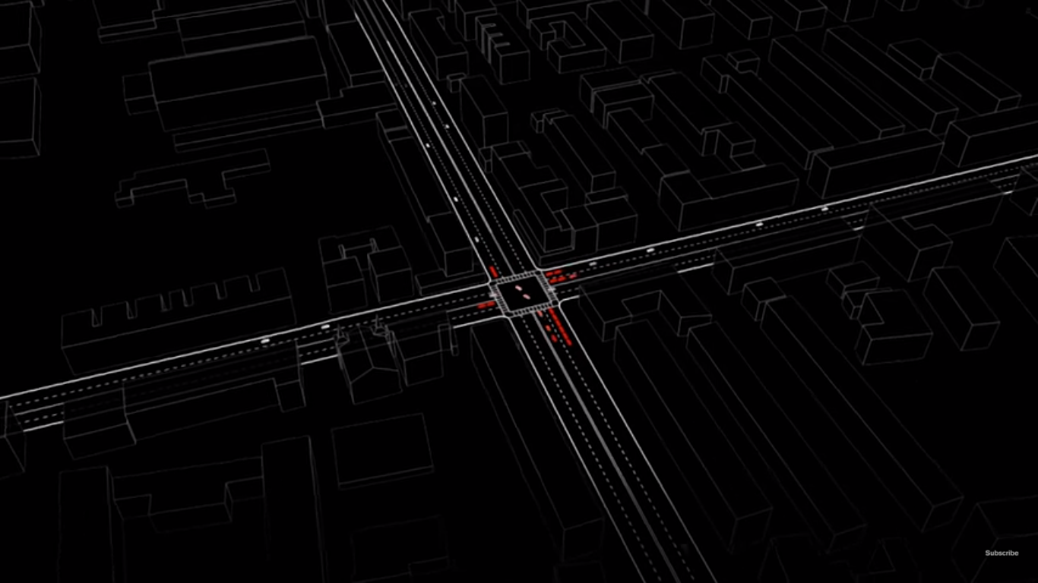

Figure 1.1: MIT Light Traffic using smart intersections

### AIM

AIM stands for Autonomous Intersection Management and was developed in 2011. This project by the University of Texas, Austin is supposed to create a scalable, safe, and efficient framework for managing autonomous vehicles at intersections. When all or most vehicles will be autonomous on the road, AIM will be suitable for such a period. AIM relies on dedicated short-range communication that talks to an intersection manager located at the intersection. The manager will allow or deny time slot requests for passing the intersection, if the request is denied, the vehicle slows down and requests again until it gets the permission, after which it can pass through the intersection safely [2].

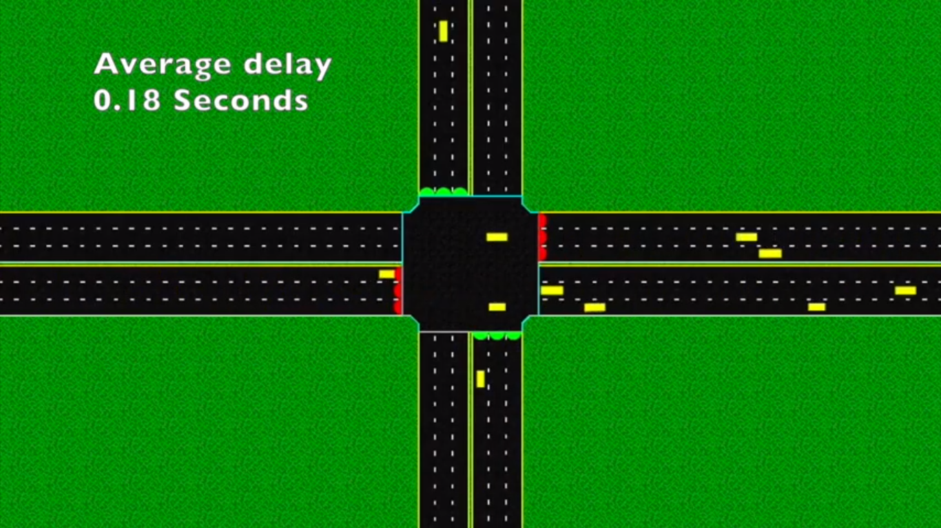

Figure 1.2: AIM simulation for 100% autonomous vehicles

### Ford’s IPMS

Ford’s Intersection Priority Management System was developed in 2018 after a study revealed that 60% of the accidents are caused by traffic signals. It uses a V2V (Vehicle-to-Vehicle) communication system which helps vehicles to avoid unnecessary stops at junctions and provides smooth traffic flow. Each vehicle shares its location, speed, and direction which are then used by the software to control the speed of the vehicle so that it can pass the intersection without stopping. Furthermore, it uses intersection collision warning technology which alerts the drivers of accidents when arriving at the intersection since this technology is being tested on partial autonomous vehicles [3].

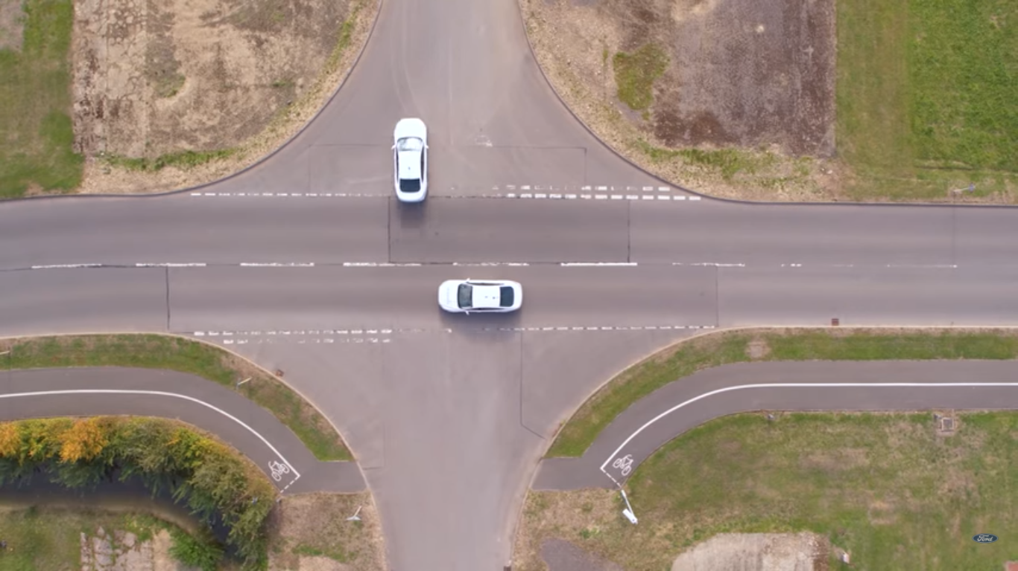

Figure 1.3: IPMS by Ford

### AJS – Comparative Analysis

Autonomous Junction Simulator will allow users to pick and choose from a range of different intersections and vehicle types. Users can change certain variables like speed and lane count. The simulator will run according to the selected parameters and the Intersection Manager will assign permissions to vehicles to allow them to use a part of the intersection at a given time frame (Permission-Based Architecture). It will be the vehicle’s responsibility to reach there on time in order to prevent unnecessary queuing and collisions. Furthermore, the entire environment will be 3-Dimensional, allowing the user to freely navigate around it. The table given below compares the features of AJS with other existing simulators. The common trend shows that all the existing simulators don’t allow users to customize the simulation so as to achieve realistic simulation.

Table 1.2: Comparative Analysis

|  |  |  |  |
| --- | --- | --- | --- |
|  | 3-D | Intersection Manager | Variable Road & Vehicles |
| MIT Light Traffic | **✗** | **✓** | **✗** |
| AIM | **✗** | **✓** | **✗** |
| Ford’s IPM | **✓** | **✗** | **✗** |
| AJS | **✓** | **✓** | **✓** |

## Project Feasibility Analysis

This section describes the ease of developing AJS in different contexts.

### Economic Feasibility

This project has been developed using software and 3-D models that are available free of charge. Thus, the development and usage of this project only require a personal computer with the necessary specifications and a valid Internet connection. So, students don’t need to invest extra money on this project since these resources are owned by all students enrolled for the bachelor’s degree in computer science at SZABIST. However, if students do not have these resources then they can use the desktop computers available at the SZABIST campus.

### Technical Feasibility

The IDE selected for developing AJS is Unity. The language natively supported by Unity is C# which has been previously used for developing various projects throughout the computer science program. Since the development team has coded programs using C# in the past, the development of AJS will be technically feasible.

### Operational Feasibility

Simulators like AJS are available but they all fail to produce a simulation with varying parameters that is closely related to real-life. The simulation produced by AJS will make it easy for countries to implement signal-less road junctions practically with a minimum error rate because of the varying parameters that make the simulation look more realistic. Moreover, the simulator is extremely easy to use and the user needs to only have the basic knowledge for operating the application.

### Schedule Feasibility

First Phase of the project: In the first phase of our Final Year Project, we will work on preparing and presenting the proposal, SRS, SDS, and initial technical document. Also, a short demonstration of the incomplete system will be presented.

Duration: February – June 2020

March 10th, 2020

Project Proposal Presentation, Approval, and Submission

April 16th, 2020

Submission of completed Software Requirements Specification Document and initial Software Design Specification Document

June 1st, 2020

Submission of final Software Requirements Specification Document, final Software Design Specification Document and initial Technical Document

June 6th, 2020

FYP-I Final Presentation

Second Phase of the project: In the second phase of our Final Year Project, we will work on completing the technical document, user manual, and the entire working project.

Duration: October 2020 – January 2021

November 30th, 2020

Submission of Test Plan and demonstration of working project

December 28th, 2020

Submission of final documentation

January 2nd, 2021

FYP-II Final Presentation and submission of all completed documents including the User Manual

### Conclusion of Feasibility Analysis

By following the above-mentioned schedule, we will be able to complete the project before the deadline. All the requirements are collected as per the perspective of the problem. We have selected reliable technologies for developing our project so that our project meets the required quality standards.

## Deliverables

* Start Screen

The user can start the simulation, change the settings, seek help in operating the application or quit the application.

* Options Screen

The user can select the types of vehicles he/she wants, their speed, intersection type, and lane count. The user can also toggle audio on/off.

* Simulation Screen

The user can move around the simulated environment, switch between camera views, reset the camera view when lost, pan the camera, zoom in or out, and return to the start screen.

## Report Orientation

This report for the Final Year Project named Autonomous Junction Simulator is composed of six chapters and 2 appendices, as described below:

1. Chapter 1: Context and Preliminary Introduction – it elucidates the project by outlining the purpose, scope, and feasibility of the project. It gives the user an overview of AJS, deliverables, and ends with the orientation of the report. It also equips the user with a brief literature review about similar existing applications.
2. Chapter 2: Research – this segment focuses on the research that was carried out ahead of time before beginning the development of AJS. It discusses the various development methodologies and tools available followed by the methodology and tool selected for this project.
3. Chapter 3: Analysis – in this system requirements chapter, a circumstantial description of all the functional and non-functional requirements for the development of AJS is specified. It familiarizes the reader with the use cases of the system and gives a thorough description of the system features.
4. Chapter 4: Design – gives an overlook of the technical design of the entire system and its components. It illustrates the design and functionality of AJS with the help of various diagrams.
5. Chapter 5: Test Plan – this chapter describes all the testing scenarios and documents the response obtained. It also mentions the risks and assumptions of the application.
6. Chapter 6: Critical Evaluation – will describe the efforts put into this project by the team members and the learning outcomes achieved throughout the duration of the Final Year Project. This section concludes the report by discussing the success rate of AJS and how the project can be improved in the future.
7. Appendix A: Glossary – provides definitions of unfamiliar, technical terms used throughout the document.
8. Appendix B: User Manual – The user manual will assist the intended users of AJS by providing them with the required information that will help them to operate the system without any difficulty.

# Chapter Two: Research



## Academic Research

### Development Methodology

To ease the development of the software, the software can be divided into separate phases which make the development process clear and manageable. There are multiple software development methodologies available.

#### Appropriate Methodologies Available

1. Waterfall Model

This is a linear model in which one phase needs to be fully completed before proceeding to the next phase. It is called the waterfall model because it follows a systematic approach where the output of the first phase is the input to the second phase. This model has 6 steps:

* + Requirements Gathering: Gathering and analyzing all the possible system requirements
  + Design: Designing system architecture based on the requirements analyzed
  + Implementation: Developing and testing the software in small pieces
  + Testing: Integrating units produced in the previous phase and testing the system for bugs
  + Deployment: Deploying the system to the customer
  + Maintenance: Maintaining the software by resolving issues that arise in the future when the customer uses it

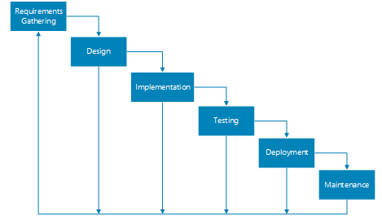

Figure 2.1: Waterfall Model

1. Spiral Model

In a spiral model, there are 4 main phases through which the project passes iteratively in a spiral. The phases are:

* Planning: Gathering and understanding system requirements for each iteration along with approximating cost, planning schedule, and identifying resources
* Risk Analysis: Identifying and mitigating risks
* Development: Developing, testing, and deploying the system
* Evaluation: Reviewing the system (done by the customer)

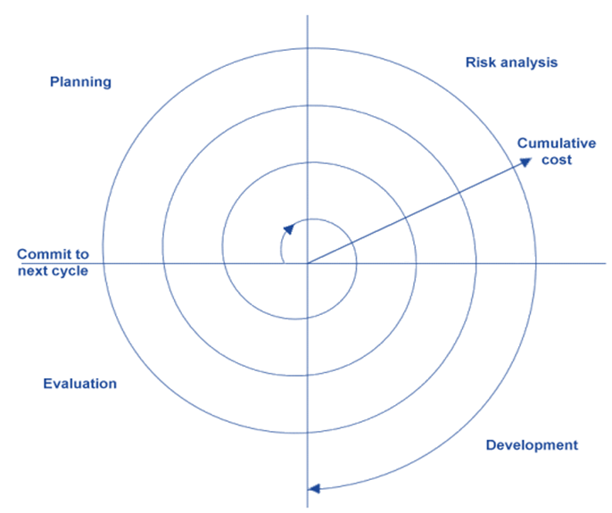

Figure 2.2: Spiral Model

1. Incremental Model

The incremental model involves the partitioning of the system into small standalone modules, each module passes through four phases to produce the software in increments:

* Analysis: Collecting and analyzing requirements
* Design: Designing the system
* Code: Coding the software
* Test: Testing the system for errors

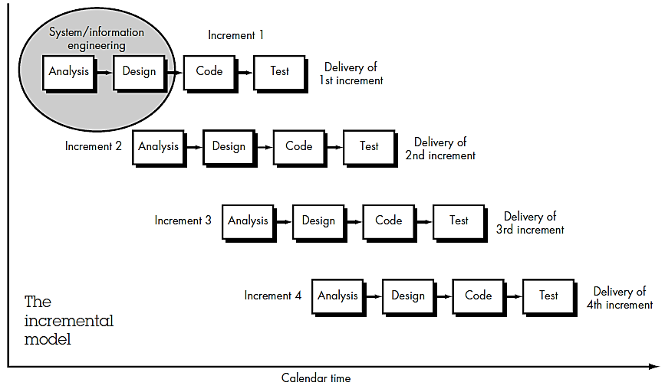

Figure 2.3: Incremental Model

1. Agile Model

This model is a combination of the iterative model and incremental model. As the name suggests, it is rapid and responds to changes quickly. The agility of this model increases customer satisfaction because the working project is delivered quickly. The software is divided into time boxes where each iteration is 2-3 weeks long and goes through the following stages:

* Requirements: Gathering all possible requirements
* Design: Designing the system
* Develop: Coding the software
* Test: Testing the software for error detection and rectification
* Deploy: Deploying the software so that the customer can use it
* Review: Receiving feedback from the customer to make further improvement

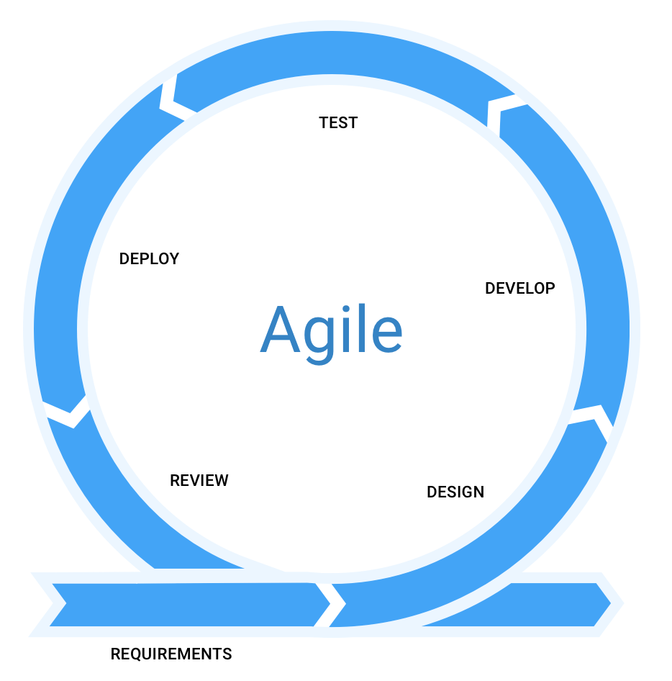

Figure 2.4: Agile Model

#### Selection of Methodology

The entire project will be developed using the Agile Methodology because it is feasible for projects that need to be developed in a year’s time and adapts to changes as well.

#### Methodology Reasoning

The agile methodology will be used to develop AJS because the agile process model provides the freedom to test and develop the system iteratively. Since this project has to be completed in a year, successive and proportionate releases of the project will have to be demonstrated on a timely basis and agile methodology is best suited for this. To build AJS, a plan will be devised using which the design of the system will be created. After which the system will be developed and tested to ascertain whether the results achieved are meeting the goal or not. The feedback from the supervisor and the results obtained from the testing phase will then be used to replan the system and the cycle continues.

After every step, changes to AJS will have to be made and this makes agile methodology the best option. Furthermore, if a new feature is to be incorporated into AJS or an existing feature is to be modified in the future, the agile methodology will make it possible.

### Development Tools

Tools are required for creating AJS and there are several tools available in the market for developing 3-D environments.

#### Appropriate Tools Available

1. Unreal Engine

Unreal Engine is an advanced tool for the creation of excellent quality games and simulations. It has been developed by Epic Games and is written in C++.



Figure 2.5: Unreal Engine Logo

1. Unity

Unity game engine is owned by Unity Technologies and supports more than twenty-five platforms. Apart from games and simulations, it is also used in media, construction, automobile, and engineering industries. It supports C#.



Figure 2.6: Unity Logo

1. Godot

Godot is an MIT licensed game engine that supports C++ and C# and runs on several operating systems. It is a cross-platform tool and allows developers to develop games from the beginning with the support of inbuilt tools.



Figure 2.7: Godot Logo

#### Selection of Appropriate Tool

AJS will be developed using Unity which is one of the leading game development platforms and supports the creation of 2-D, 3-D, VR, and AR applications.

#### Development Tool Reasoning

Unity has been selected for the development of AJS because it has a big and strong community that provides support to users during the development process by resolving issues quickly. Moreover, it has an asset store where free and paid 3-D models are available for download and usage. This will make AJS development hassle-free and cost-free. Additionally, it is free for small scale projects and has fast debugging.

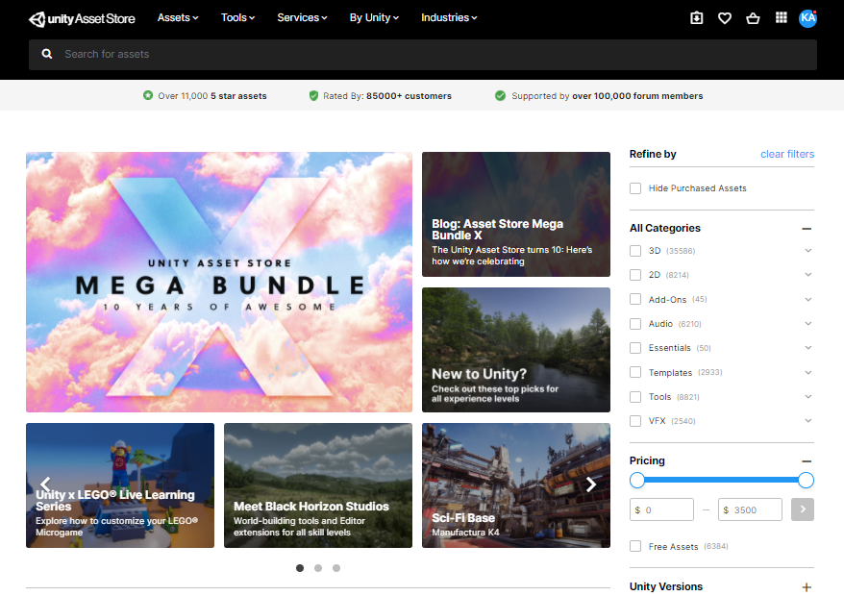

Figure 2.8: Unity Asset Store

Since a few 3-D models are paid and need to be purchased for utilization, CGTrader will be accessed frequently for downloading free 3-D models. CGTrader provides users with filters to enhance their searching experience. It enables users to select the 3-D model category and provides a list of .fbx 3-D models that are compatible with Unity. However, blender 3-D models will also be used.

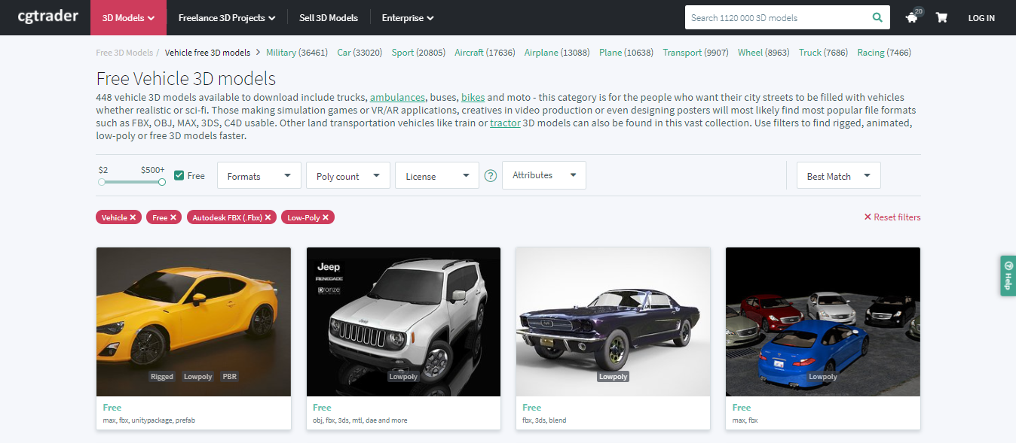

Figure 2.9: CGTrader showing free 3-D vehicle models

VS Code will be used for writing scripts as it is free and allows easy debugging by highlighting the errors. It is a very light tool with code auto-completion abilities. It is developed by Microsoft and can be used for several operating systems.

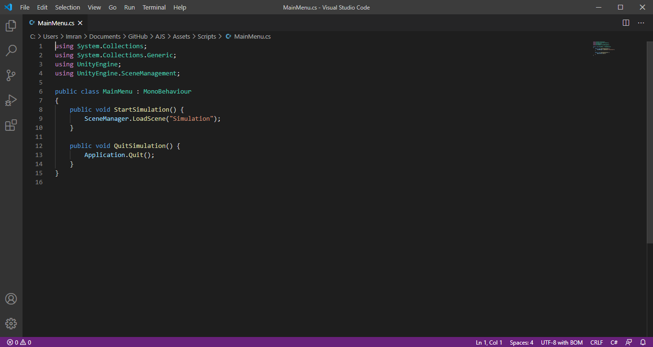

Figure 2.10: Visual Studio Code

The documents will be prepared using Google Docs and then will be formatted in Microsoft Word for submission. Presentations will be created using Google Slides. All the documents and presentations will be uploaded onto Google Drive to allow the team members to collectively contribute to them. To create the diagrams for the document, Creately will be used.

Finally, a private repository will be created on GitHub and the project will be pushed onto it during the development process. GitHub will allow the team members to work on the same project together and will make the development process fast since changes can be made to the project easily. Commits will be pushed and pulled regularly to ensure the team members are on the same page.

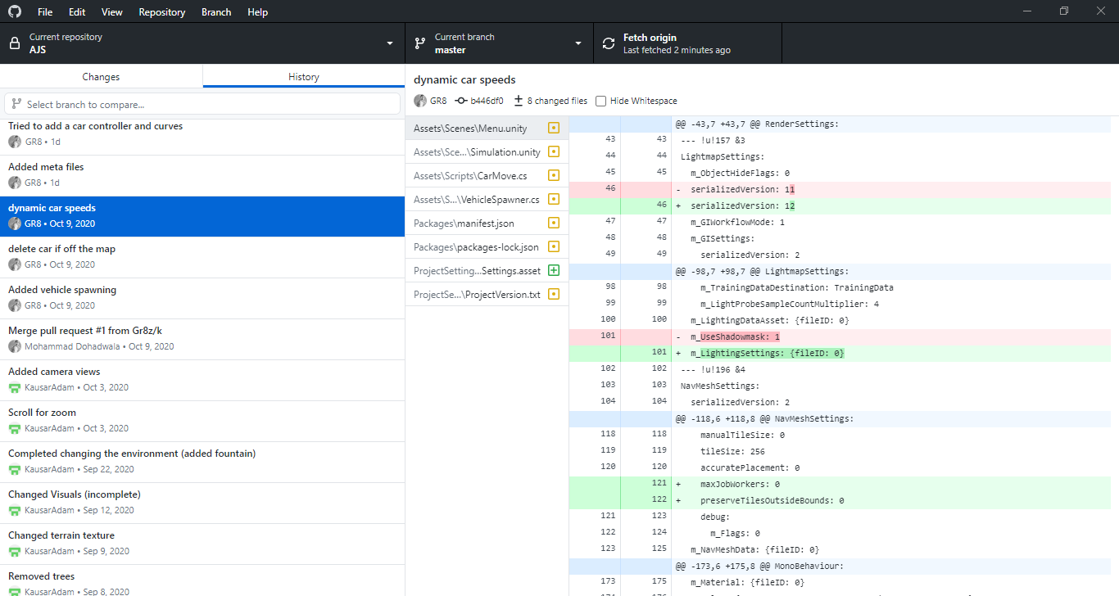

Figure 2.11: GitHub Desktop displaying the history of changes made to AJS

# Chapter Three: Analysis



## User Requirements / Use Cases

Table 3.1: Use case for Main Menu

|  |  |  |  |  |
| --- | --- | --- | --- | --- |
| <Use case UC-Men-01: Main Menu> | | | | |
| **Use case Id** | | | UC-Men-01 | |
| **Actors** | | | User | |
| **Feature** | | | This feature will display the main menu when the user starts the application. The user will be able to select the options by clicking on them. | |
| **Pre-condition** | | | The user must have the application downloaded and started on his/her Windows system. | |
| **Scenarios** | | | | |
| **Step #** | **Action** | | | **Software Reaction** |
| **1.** | The user clicks on the START button | | | The application will display the simulation based on the settings that were selected by the user or that were previously selected in the last run. |
| **2.** | The user clicks on the OPTIONS button | | | The user will be redirected to the options menu where a list of parameters will be displayed. |
| **3.** | The user clicks on the HELP button | | | A help section will be displayed acknowledging the user about how the application works and how the options selected by the user will affect the simulation. |
| **5.** | The user clicks on the QUIT button | | | The application will close. |
| **Alternate Scenarios** | | | | |
| **1. The user does not have Windows 7 or higher:**  In this case, the application will not be compatible with the system and will not start. | | | | |
| **Post Conditions** | | | | |
| **Step #** | **Description** | | | |
| **1** | If the user has started the simulation and presses the ‘ESC’ button from the keyboard then the main menu will be displayed. | | | |
| **Use Case Cross referenced** | | None | | |

Table 3.2: Use case for Options Menu

|  |  |  |  |  |
| --- | --- | --- | --- | --- |
| <Use case UC-Opt-01: Options Menu> | | | | |
| **Use case Id** | | | UC-Opt-01 | |
| **Actors** | | | User | |
| **Feature** | | | This feature will display the options menu when the user clicks on the options button from the main menu. The user will be able to set the parameters according to his/her preferences. | |
| **Pre-condition** | | | The user must have the application downloaded and started on his/her Windows system. | |
| **Scenarios** | | | | |
| **Step #** | **Action** | | | **Software Reaction** |
| **1.** | The user clicks on the OPTIONS button from the main menu | | | The application will respond to this request by displaying the options menu. The options menu will consist of several parameters that can be modified. |
| **2.** | The user sets the speed using the speed slider | | | When the speed slider is moved towards the left, the vehicle speed will reduce, and when the speed slider is moved towards the right, the vehicle speed will increase. |
| **3.** | The user checks or unchecks the boxes for vehicle type | | | The user will be able to select the type of autonomous vehicles he/she wants in the simulation. The vehicle checked will be displayed in the simulation and the vehicle unchecked will be removed from the simulation. |
| **4.** | The user selects the number of roads from the drop-down menu | | | The user will then select the number of roads he/she wants in the simulation. The simulation will display 3 or 4 roads based on the user’s selection. |
| **5.** | The user selects the number of lanes from the drop-down menu | | | The user will select the number of lanes the roads will have in the simulation. If the number of lanes is set as 4, then 2 lanes will be for traveling towards the intersection and 2 will be for moving away from the intersection. |
| **6.** | The user toggles audio on/off | | | When the box is checked, the audio will start playing in the background. Else, it’ll stop. |
| **7.** | The user clicks on the Done button | | | When the user has set all the parameters, the user will click on the Done button. This will take the user back to the main menu. |
| **Alternate Scenarios** | | | | |
| **1. The user does not have Windows 7 or higher:**  In this case, the application will not be compatible with the system and will not start. | | | | |
| **Post Conditions** | | | | |
| **Step #** | **Description** | | | |
| **1** | The user will be taken back to the main menu where he/she can click on start to display the simulation, click on help for support or can click on quit to exit. | | | |
| **Use Case Cross referenced** | | None | | |

Table 3.3: Use case for Camera Views

|  |  |  |  |  |
| --- | --- | --- | --- | --- |
| <Use case UC-Cam-01: Camera Views> | | | | |
| **Use case Id** | | | UC-Cam-01 | |
| **Actors** | | | User | |
| **Feature** | | | To view the simulation, users have the option to select from three separate camera views. The users can select whether they want to move around or they want a view of all the cars in the simulation or they want to experience a view of a pedestrian at the intersection. These views are called fly camera, bird’s-eye and first-person view. The bird’s-eye view enables users to see the entire environment from the top and gives them a clear vision. The first-person view will enable users to see the intersection as a pedestrian would. | |
| **Pre-condition** | | | The user must have pressed the start button from the main menu. | |
| **Scenarios** | | | | |
| **Step #** | **Action** | | | **Software Reaction** |
| **1.** | The user presses the button ‘1’ from the keyboard | | | The software will enable the fly camera using which the user can move around the simulated environment. |
| **2.** | The user presses the button ‘2’ from the keyboard | | | The software will shift to a fixed bird’s-eye view which will show a view of the entire environment from the top. |
| **3.** | The user presses the button ‘3’ from the keyboard | | | The software will shift to a fixed first-person view where the camera will be positioned near the junction. The view will be similar to what a pedestrian would see. |
| **Alternate Scenarios** | | | | |
| **1. The user does not have Windows 7 or higher:**  In this case, the application will not be compatible with the system and will not start. | | | | |
| **Post Conditions** | | | | |
| **Step #** | **Description** | | | |
| **1** | When the user is in the bird’s-eye or first-person view, the user will not be able to move around the 3-D environment until he/she doesn’t activate the fly camera by pressing ‘1’. | | | |
| **Use Case Cross referenced** | | None | | |

Table 3.4: Use case for Fly Camera

|  |  |  |  |  |
| --- | --- | --- | --- | --- |
| <Use case UC-Cam-02: Fly Camera> | | | | |
| **Use case Id** | | | UC-Cam-02 | |
| **Actors** | | | User | |
| **Feature** | | | This feature will allow the users to move around and explore the 3-D environment. | |
| **Pre-condition** | | | The user must be on the fly camera mode. | |
| **Scenarios** | | | | |
| **Step #** | **Action** | | | **Software Reaction** |
| **1.** | The user presses the WASD buttons from the keyboard | | | The software will allow the user to move the camera inwards, left, outwards, and right. |
| **2.** | The user clicks, holds and drags the left mouse button | | | The software will respond to this by tilting the camera in the direction the mouse is swayed. |
| **3.** | The user moves the scroll wheel up and down | | | The software will change the z-axis values of the camera to allow the user to zoom into and out of the view. |
| **4.** | The user presses the ‘R’ button from the keyboard | | | The camera will be repositioned to its starting location. |
| **Alternate Scenarios** | | | | |
| **1. The user does not have Windows 7 or higher:**  In this case, the application will not be compatible with the system and will not start.  **2. The user is using the touchpad for scrolling:**  In this case, the user will not be able to zoom in or out because the zooming feature works only with the scroll wheel and not with the touchpad.  **3. The user is unable to move around:**  This will happen if a problem exists in the hardware of the host machine or the user is not on the fly camera mode. | | | | |
| **Post Conditions** | | | | |
| **Step #** | **Description** | | | |
| **1** | The camera will move around depending on the action performed by the user and will not leave the terrain. | | | |
| **Use Case Cross referenced** | | None | | |

Table 3.5: Use case for Intersection Manager

|  |  |  |  |  |
| --- | --- | --- | --- | --- |
| <Use case UC-IM-01: Intersection Manager> | | | | |
| **Use case Id** | | | UC-IM-01 | |
| **Actors** | | | User | |
| **Feature** | | | This feature will manage all the autonomous vehicles and prevent them from colliding when they cross the junction. | |
| **Pre-condition** | | | The user must have the simulation started. | |
| **Scenarios** | | | | |
| **Step #** | **Action** | | | **Software Reaction** |
| **1.** | The user presses the START button from the main menu | | | The software will create a simulated environment with the roads, lanes, and vehicles the user had selected. Vehicles will get randomly spawned on the road and they will travel in their own lanes to cross the junction without colliding with each other, with the aid of an Intersection Manager. |
| **Alternate Scenarios** | | | | |
| **1. The user does not have Windows 7 or higher:**  In this case, the application will not be compatible with the system and will not start. | | | | |
| **Use Case Cross referenced** | | UC-Opt-01 | | |

## Use-Case Diagrams

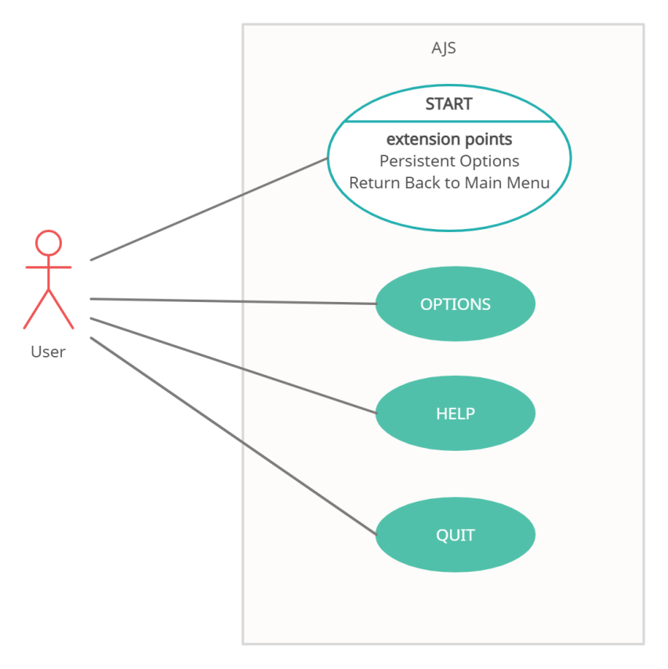

Figure 3.1: Use case diagram for Main Menu

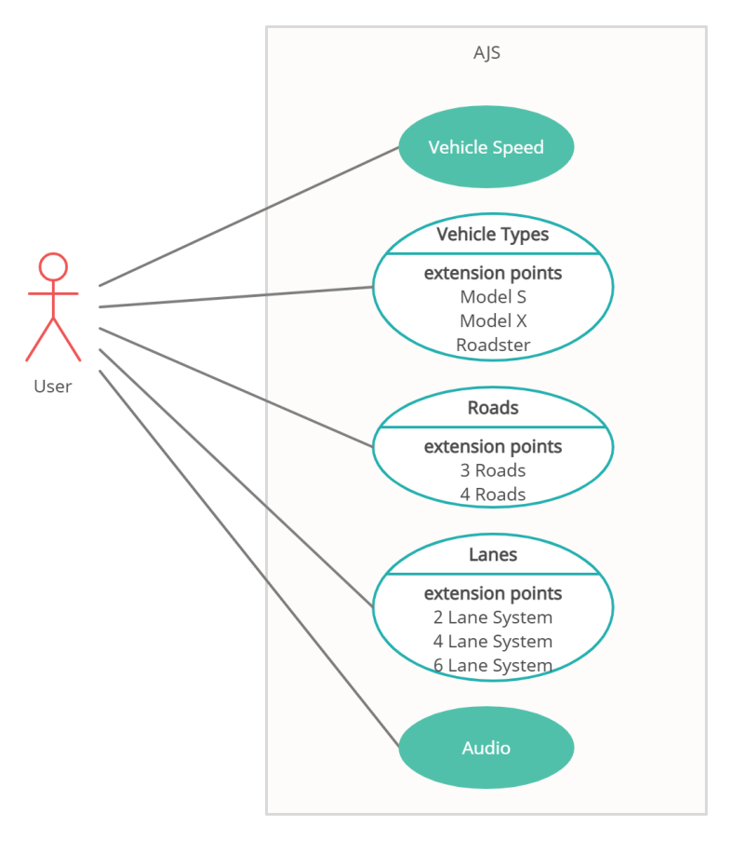

Figure 3.2: Use case diagram for Options Menu

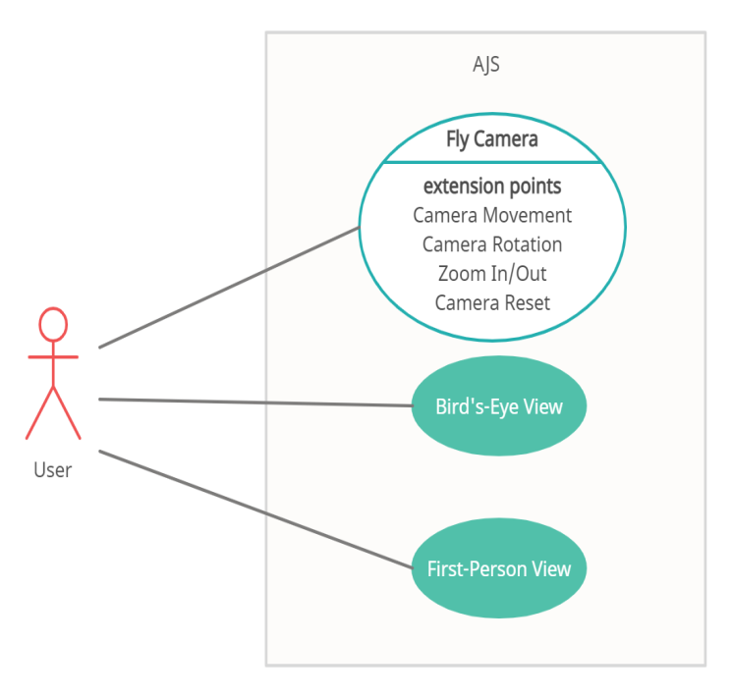

Figure 3.3: Use case diagram for Camera

## System Specifications

### Functional Requirements

* Main Menu: The application will display a main menu on start-up to allow users to select whether they want to start the simulation, change the parameters, access the help section or quit the application.
* Varying Parameters: This is the main feature that differentiates AJS from other similar simulators. AJS will allow users to access the varying parameters on the options menu via the main menu. The user will be able to set the speed at which the vehicles will travel, the types of autonomous vehicles the simulation will consist of (different vehicle models), the number of roads in the simulation (3 or 4), the number of lanes the roads will have (2, 4 or 6) and whether the user wants background music or not.
* Persistent Data: This feature will be added to avoid any sort of error when the user begins the simulation without first selecting the parameters. The state of the previously selected settings will be saved and will be used to produce a simulation when the user does not modify the parameters in the options menu before starting the simulation.
* Simulation Creation: This feature will create a simulation based on the default parameters or the parameters set by the user
* Vehicle Autonomy: This is another high priority feature. AJS will only consist of AVs and to fulfill this feature, car controller will be used to ensure that the vehicles move on their own, PID controller will be used to move vehicles in their respective lanes and waypoints will show the vehicles their path.
* Vehicle Spawning: This feature will facilitate in generating all types of vehicles randomly at the start of all roads that lead them towards the intersection.
* Collision Detection System: The codebase of the application will ensure that the vehicles do not collide with each other throughout the simulation. The vehicles will communicate with the Intersection Manager to cross the junction following the waypoints that have been placed on the intersection for successful turning. The Intersection Manager will keep predicting the position of the vehicle and perform a collision test to see whether the vehicles will collide at the junction or not. If the test succeeds, the vehicles will cross the junction otherwise, they will stop.
* Vehicle Destruction: Once a vehicle crosses the intersection and reaches the end of the road, the vehicle will be destroyed to prevent it from falling off the terrain.
* Fly Camera Movement: With this feature, the users will be able to move around the fly camera by using the keyboard keys so that they can explore the entire 3-D environment. This will be done by altering the position values of the x, y, and z-axis
* Fly Camera Rotation: The user will be allowed to hold the view generated by the camera and drag it in the 3-D space to alter the rotation values of the fly camera
* Fly Camera Zoom: The application will zoom into and out of the scene when the user uses the scroll wheel of the mouse. This operation will be performed by altering the z-axis value of the camera.
* Reset Fly Camera: It is very likely that the user will get lost when moving around the 3-D environment or be stuck in a certain position where the difficulty to return back arises. In this case, this feature will allow the user to reset the fly camera’s position back to where it was located at the beginning.
* Return: This feature will allow the user to return to the main menu on a key’s press. The user can then select the options he/she wants from the main menu.
* Fly Camera Movement Restriction: The entire road structure is built on a terrain that is placed in the vast, infinite 3-D environment of the Unity game engine. To prevent the user from moving the camera off the terrain, restrictions will be added to the fly camera position values.
* Bird’s-Eye View: This feature will consist of a camera positioned at the top of the terrain. The bird’s-eye view will allow the user to see a clear view of all the vehicles before they reach the junction, at the junction, and after they have crossed the junction. The view will enable users to see the entire environment from the top and will give them a clear vision of how all vehicles pass without colliding with each other. The user, however, will not be able to move around in this camera view.
* First-Person View: The first-person view will enable users to see the intersection as a pedestrian would. The user will be able to see a clear view of vehicles crossing the intersection in their desired direction. This view will make them feel like a pedestrian who is standing at the junction and watching the vehicles pass by. The user will be able to focus only on how the vehicles are crossing the junction rather than seeing all the elements of the simulation. The user, however, will not be able to move around in this camera view.
* Help: The help section will be accessible from the main menu and will list out the details regarding the usage of the application.
* Quit: This feature will close the application.

### Non-Functional Requirements

#### Nature of the users

The following users will be using AJS:

1. Vehicle and Transport Department: Since AJS is a simulator, the Vehicle and Transport Department of all countries can use it to plan the infrastructure of road junctions. They can alter the variables according to the area for which they are planning to build the junction, and can test the scenarios on the simulator. AJS will be a convenient platform for these users and will help them wisely plan their designs. They will be using AJS frequently to obtain reliable results and to ensure that when the junction is implemented on the road, the outcome will be favorable. This makes them the most important user class to be satisfied since this project revolves around the simulation of road junctions.
2. Self-driving car manufacturers: Many big companies like Google are developing and testing autonomous vehicles. Since AJS gives users the freedom to select their vehicle type, these companies or manufacturers can use AJS to test the efficiency of their produced vehicles when road junctions without traffic signals will be implemented.
3. Researchers: Researchers from various organizations like MIT and the University of Texas can use AJS for their research purposes. They can use the results obtained from AJS in their research papers and suggest improvements to make AJS a more robust simulator.

#### Performance Requirements

AJS will demand high GPU power as well as CPU for algorithms and 3-D rendering. To ensure the simulation runs smoothly, AJS requires a computer with a good graphics card and a recent generation CPU. Applications running in the background that are demanding in CPU and graphics will also affect the performance of the simulation.

### Quality Attributes

The simulation relies on the accuracy of real-life physics like friction, velocity, and other dynamics that affect a moving car. The simulation should fail if vehicles crash or collide with each other. Lastly, the 3-D environment should be textured life-like and should represent an intersection that could be used in a physical space.

#### Maintainability

The structure used to develop this application makes the maintainability of AJS extremely easy.

#### Simplicity

The backend of AJS consists of coding that will be difficult for users to understand, however, the user interface is amicable and promotes usability. The users can easily navigate through the application without any difficulty with the help of the help section in AJS.

#### Extensibility

The structure used for developing AJS makes it easy for the application to be extended further in the future. The application can be enhanced in the future by adding new features and the existing functionalities will not be affected.

#### Safety Requirements

The simulation produced by AJS is only for fully autonomous cars and is not 100% accurate since AJS lacks parameters that may affect the outcome obtained. Thus, it will be dangerous if users use the resulting simulation to develop intersections without traffic lights in real-life.

### Domain Requirements

This project’s domain has a requirement of a computer system with Windows 7 or above.

### Interface Requirements

#### User Interface

The user interface of AJS will be user friendly to ensure that users face no difficulty in navigating through the simulator and its features. In order to achieve a smooth experience, users need to be able to read the help section and have basic knowledge about using buttons and similar tools to modify the parameters.

In AJS, the user will be able to move around the 3-D space using their mouse and keyboard to tilt the camera and move forward/backward. This way the user can go up to see the bird’s-eye view or come closer to the intersection to see the first-person perspective of the cars. AJS will also let the user control the scenario using the settings panel at the start of the simulation.

W, A, S, D keys will move the camera forward, left, backward, and right.

Right-clicking and dragging will tilt the camera in the direction the mouse is swayed.

The scroll wheel will control the zoom of the view.

#### Hardware Interface

AJS does not have any hardware interfaces since it is a software-based system and is not bound to any hardware components other than a computer system with the required performance specifications mentioned earlier.

#### Software Interface

AJS will use Windows as its base OS for the simulation application. The programming language used for this program will be C#, as that’s what's natively supported by the Unity 3-D platform. The application will not have any persistent database and the state will be stored in the memory while the simulation is running.

There will be no communication over the internet. However, there will be a local simulated server called the intersection controller. It will enable two-way communication from vehicles to the server and vice versa.

#### Communication Interface

To download AJS, an active internet connection is required. Once downloaded, it can run offline. Using AJS does not require users to create an account or log in; users can directly proceed to use the simulator once it has been downloaded on their system and explore the features.

# Chapter Four: Design



## Architectural Strategies

AJS is a simulator that will allow vehicles to cross the intersection safely by ensuring that they don’t collide. The user will be presented with a settings panel at the start of the system, using which the user can select the parameters according to his/her preferences. AJS will be built using the following design decisions:

* Object-oriented software design

This strategy focuses on the objects of the program and makes the development of the system fast and easy because the components are presented in a structured manner which makes it easy to search for them in the program. Another reason for the selection of this strategy is that the code can be reused throughout the program which eliminates the need to type the code multiple times. Bugs that arise in the system will be resolved and will be released on a webpage to download and run. In the future, more parameters can be added to the settings panel along with better animation. Since AJS will be developed on Unity 3-D, C# will be the programming language used for scripting because it is an object-oriented programming language and it is supported by Unity.

* Permission-based architecture

PBA will be used by the intersection manager to allow fully autonomous vehicles to pass the intersection. The vehicles approaching the junction will communicate with the intersection manager that is placed at the center. The vehicles will share the direction in which they want to travel with the intersection manager and based on the condition of the intersection, the manager will either accept their request or will reject it. If the collision test carried out for the requesting vehicle shows no chances of collisions then the vehicle will be granted permission to cross. On the other hand, if the collision test fails then the request of the vehicle will be rejected. This will result in deceleration of the vehicle and the intersection manager will keep repeating the collision test for that vehicle until the vehicle does not succeed in the test.

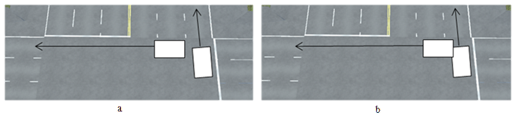

Figure 4.1: Collision Test when it (a) Succeeds and (b) Fails

* PID Controller

This is a controller that will ensure that the vehicles travel only in their respective lanes. It has 3 components:

* + Proportional (P): This component calculates the current steering wheel value and compares it with the value fed into the system. If the current value calculated using the error is very far from the value fed into the system, then the vehicle will be steered in the opposite direction. This results in the oscillation of the AV. However, if the error calculated is zero, then no action will be required since it means that the actual and expected values coincide.
  + Integral (I): This component keeps integrating the error that was calculated in the proportional component until it reaches zero. This will help the vehicle stay on the desired path by affecting the force with which the vehicle is steered.
  + Derivative (D): The error is being calculated and corrections are made continuously. This means that the P and I factors of the controller will keep reducing and correcting the error, the more they work, the more the vehicle will oscillate. The D component will predict the future value and add a damping effect to the vehicle to reduce its oscillation.

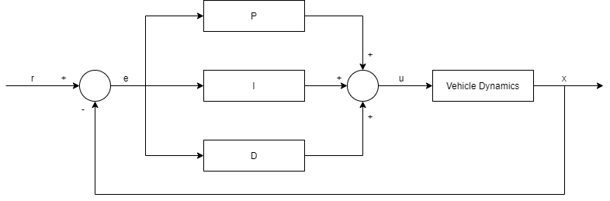

Figure 4.2: Block Diagram of the PID Controller

## Deliverables of Process Modeling

### Context Diagram



Figure 4.3: Context Diagram of AJS

### System Architecture

AJS takes input from the users in the form of varying parameters through the settings screen accessed via the menu. The user will make selections for the vehicle types, their speeds, number of roads (intersection type), and the lane count for each road. Once configured, a simulation of the intersection will be displayed with the help of the 3-D environment developed in Unity. The final simulation will portray how vehicles are crossing the junction without colliding using the parameters the user had selected.

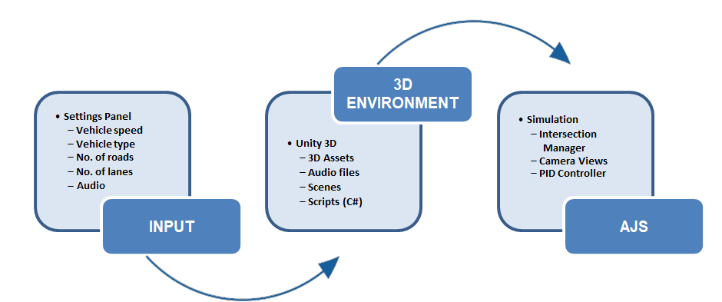

Figure 4.4: System Architecture of AJS

To create the entire 3-D environment and display the simulation, lots of files are required. 3-D assets and objects are used to create a life-like environment for the simulation so that it looks real and similar to the actual world. The 3-D assets contain objects for vehicles, roads, pavements, and street objects like buildings, trees, water fountain, etc… Audio files are used to play music in the background. To make the whole thing interactive and moving, scripts are used. Scripts contain the C# program code that is linked to the objects of the simulation. All these components are combined to form scenes. There are various scenes available in AJS and all serve a different purpose. The Menu scene provides buttons to start the simulation, quit it, access help section and edit the parameters. The help screen provides details and usage instructions about AJS to familiarize the user with the 3-D simulator. The settings scene lists down all the parameters that the user can modify and the simulation scene simulates the entire thing.

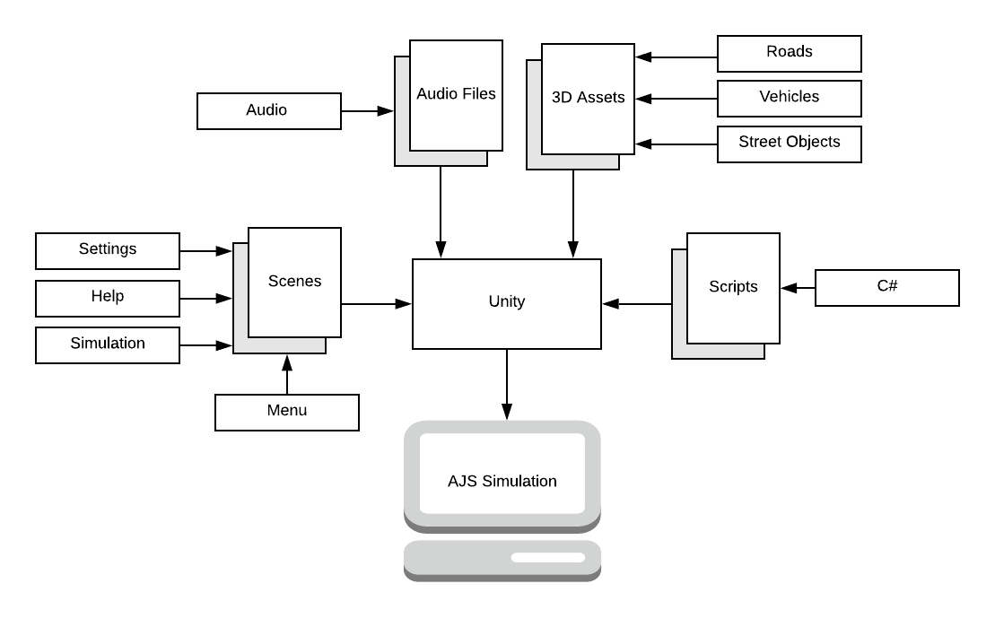

Figure 4.5: Architecture of the 3-D environment

### Sequence Diagram

**Starting the Simulation**

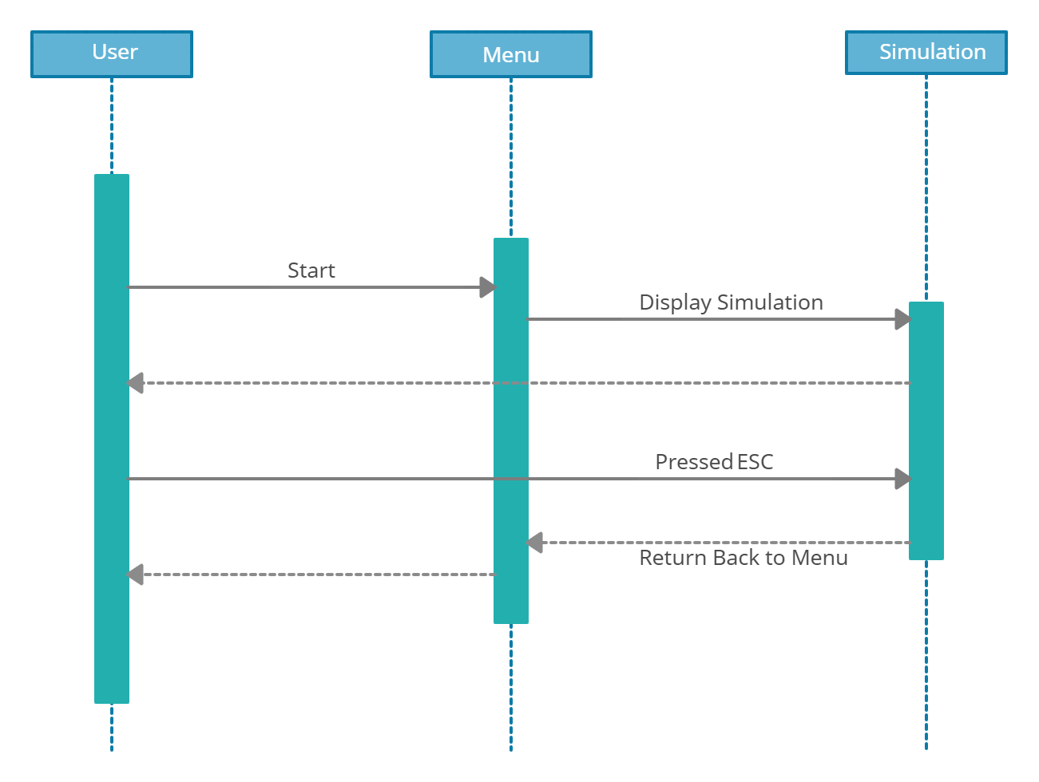

Figure 4.6: Sequence Diagram for Starting the Simulation

**Selecting Options**

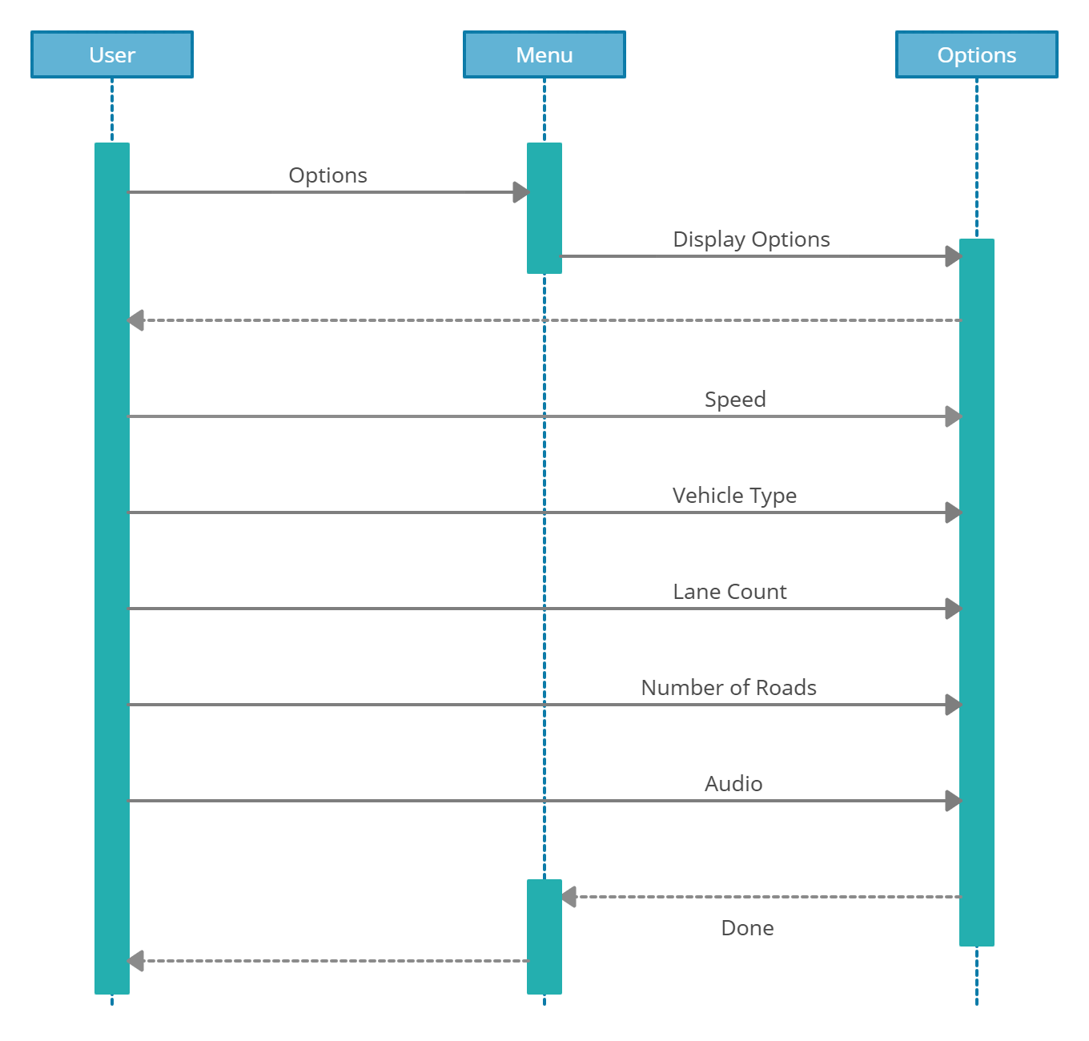

Figure 4.7: Sequence Diagram for Selecting Options

**Help Section**

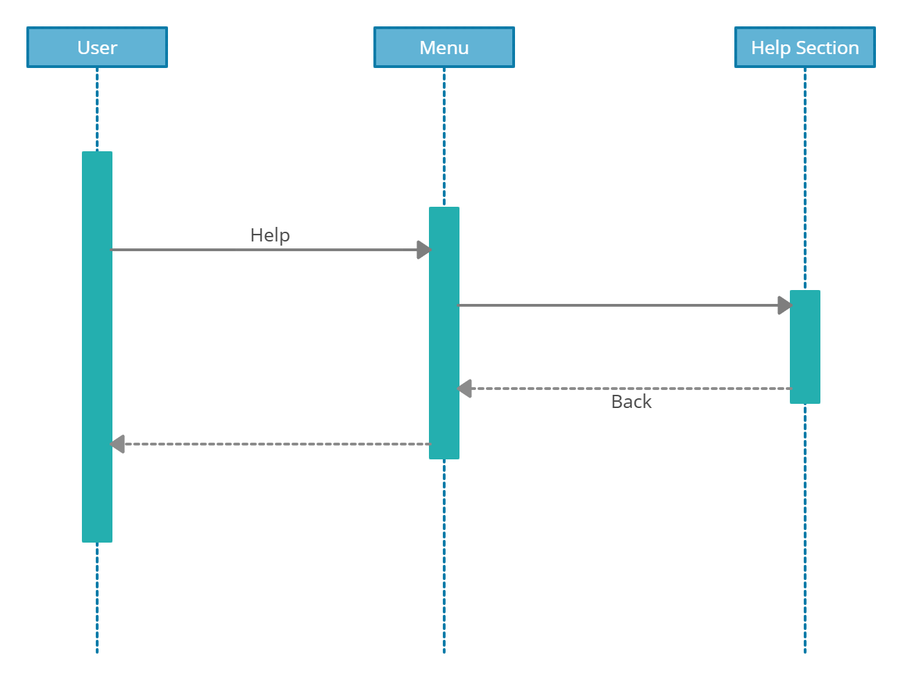

Figure 4.8: Sequence Diagram for Accessing the Help Section

**Quit**

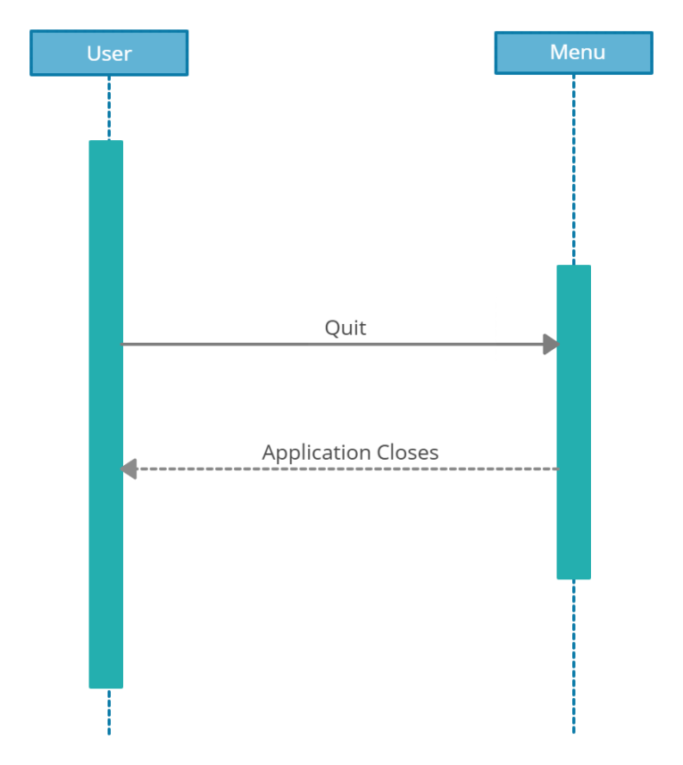

Figure 4.9: Sequence Diagram for Exiting the Application

**Camera Views**

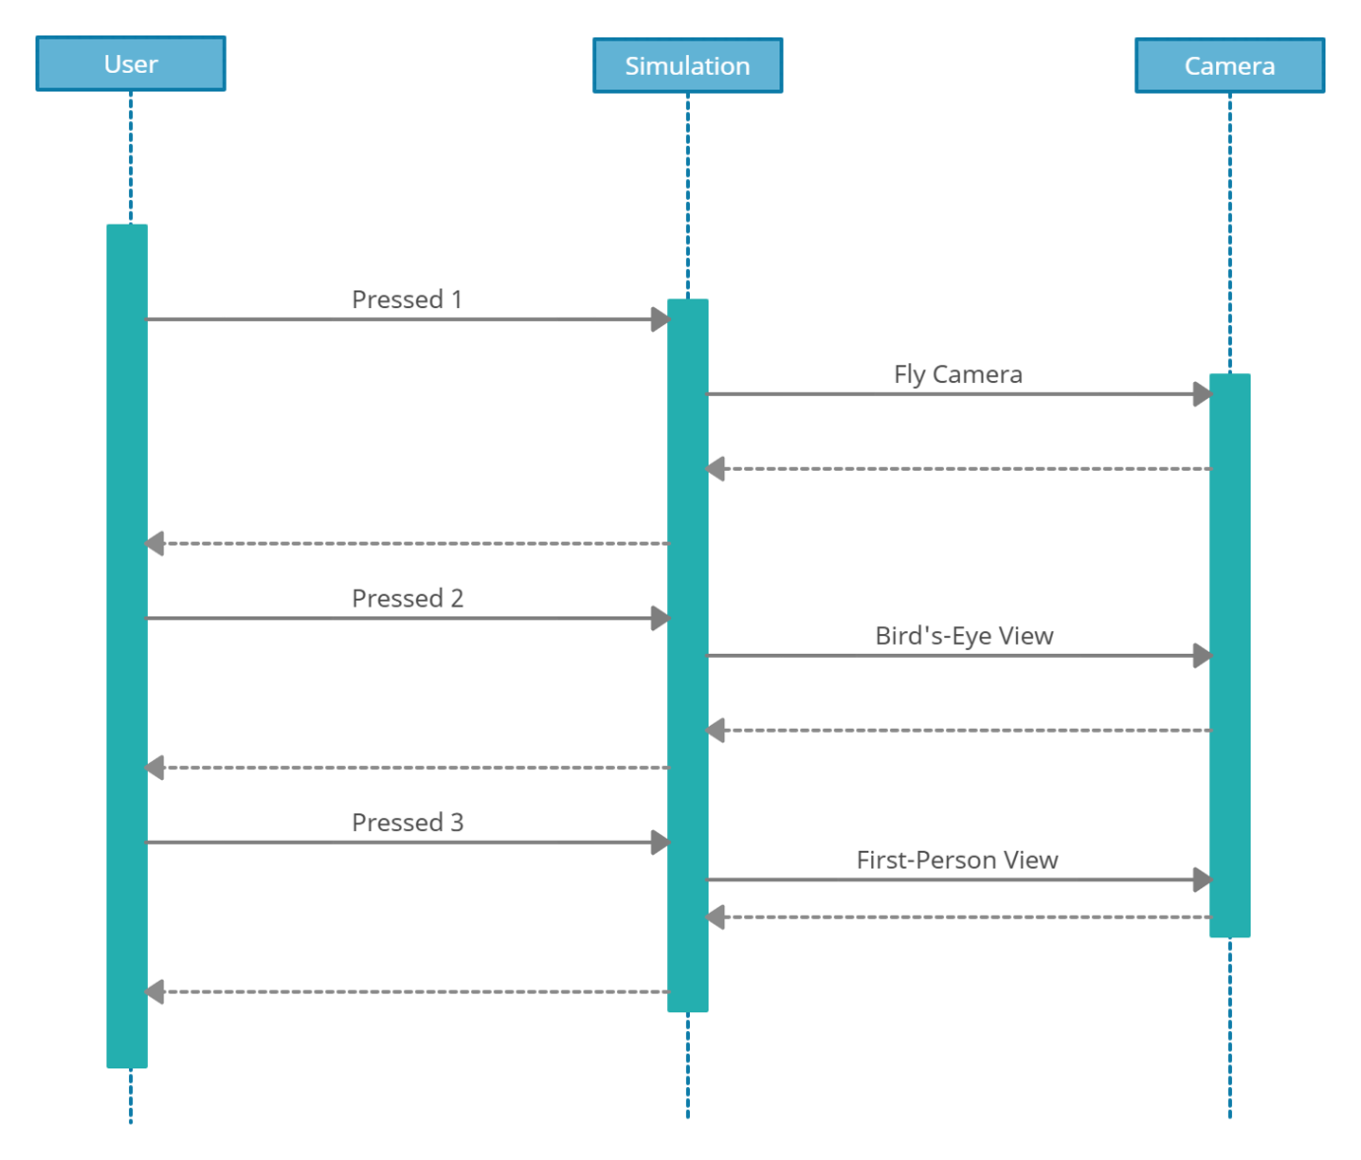

Figure 4.10: Sequence Diagram for Camera Views

**Fly Camera Movement**

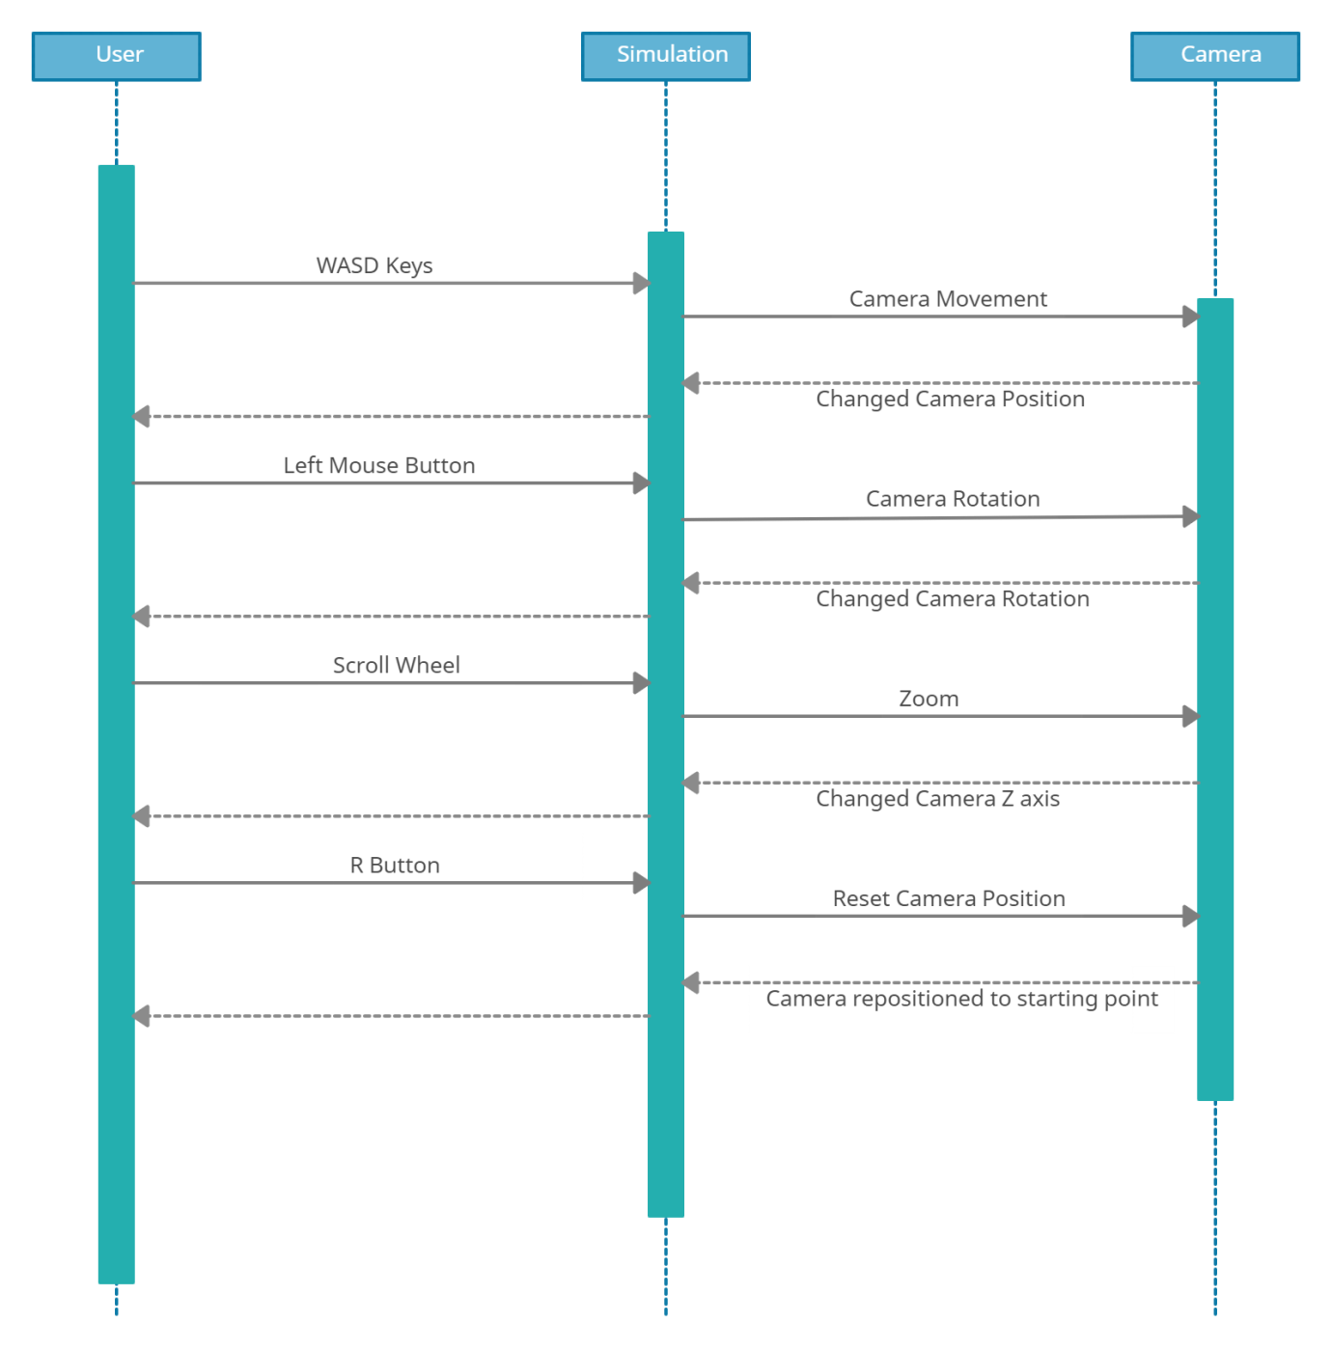

Figure 4.11: Sequence Diagram for Fly Camera Movement

### State Chart Diagram

**Starting the Simulation**

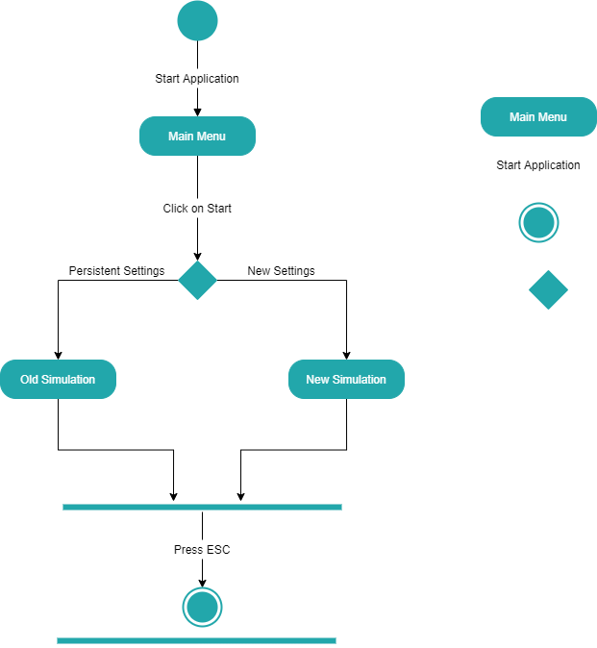

Figure 4.12: State Chart Diagram for Starting the Simulation

**Selecting Options**

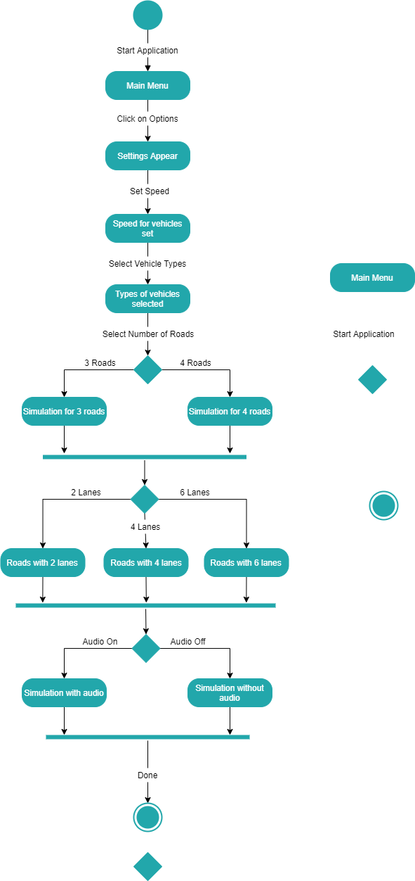

Figure 4.13: State Chart Diagram for Selecting Options

**Help Section**

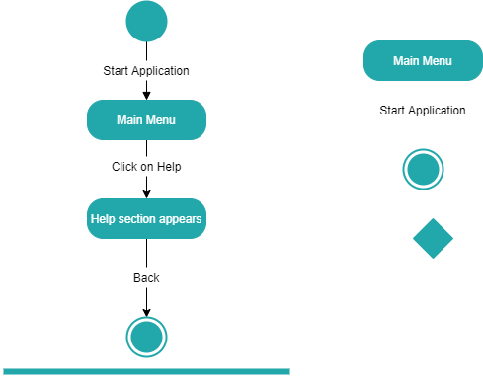

Figure 4.14: State Chart Diagram for Accessing the Help Section

**Quit**

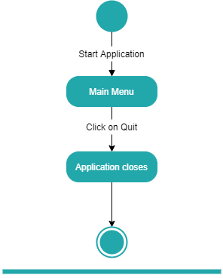

Figure 4.15: State Chart Diagram for Exiting the Application

**Camera Views**

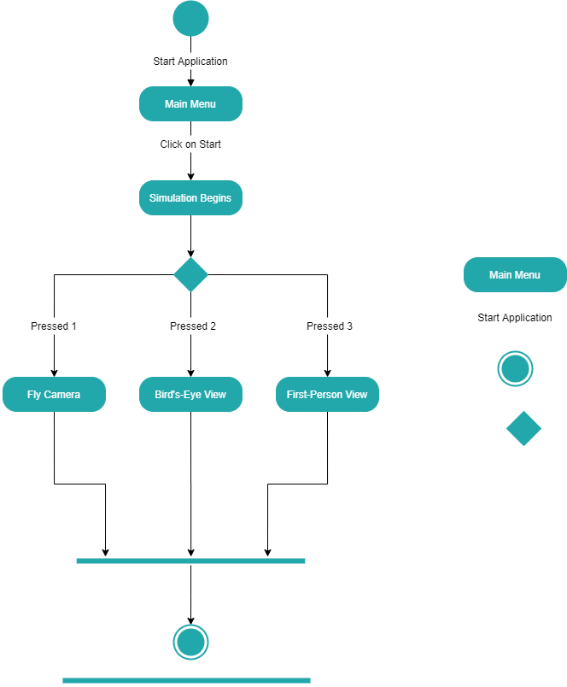

Figure 4.16: State Chart Diagram for Camera Views

**Fly Camera Movement**

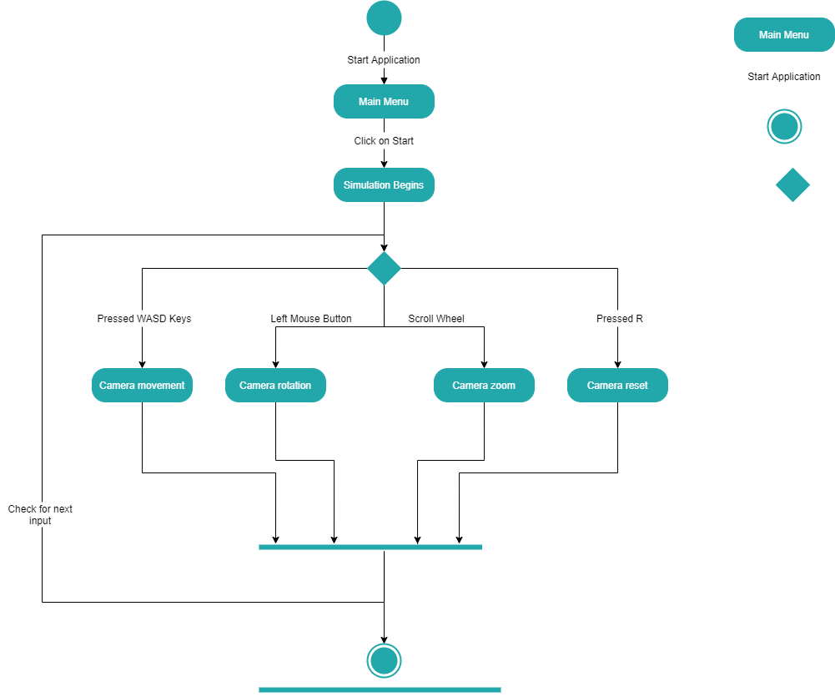

Figure 4.17: State Chart Diagram for Fly Camera Movement

**Intersection Manager**

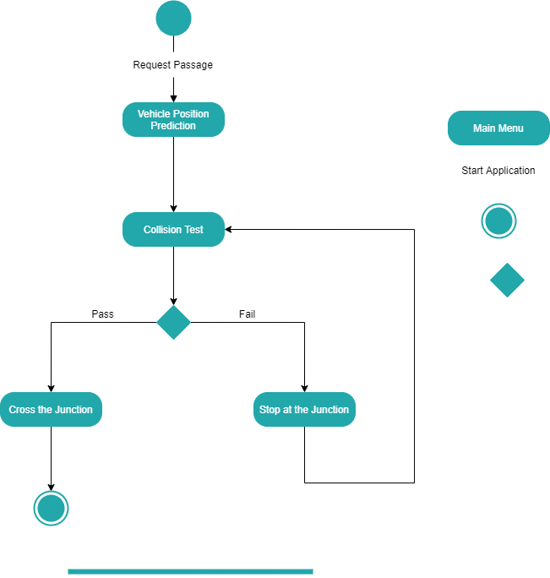

Figure 4.18: State Chart Diagram for Intersection Manager

## Policies and Tactics

AJS will be using the latest version of Unity 3-D available at the time of development as a main platform and tool to develop and build the simulator. All the logic and scripts will be coded in C# using Visual Studio Code.

The codebase will consist of a mixture of functional and object-oriented programming. And, the Agile Method will be used to push changes and fix bugs. The newest version will be available for download and use from a web page accessible on the internet.

The testing and maintenance of the software will be a recurring process after the first stable version is released. Testing will be done internally or by getting feedback from users. Once a fix is released, semantic versioning will be used to organize the releases.

## GUI’s/Prototype

**Main Menu**

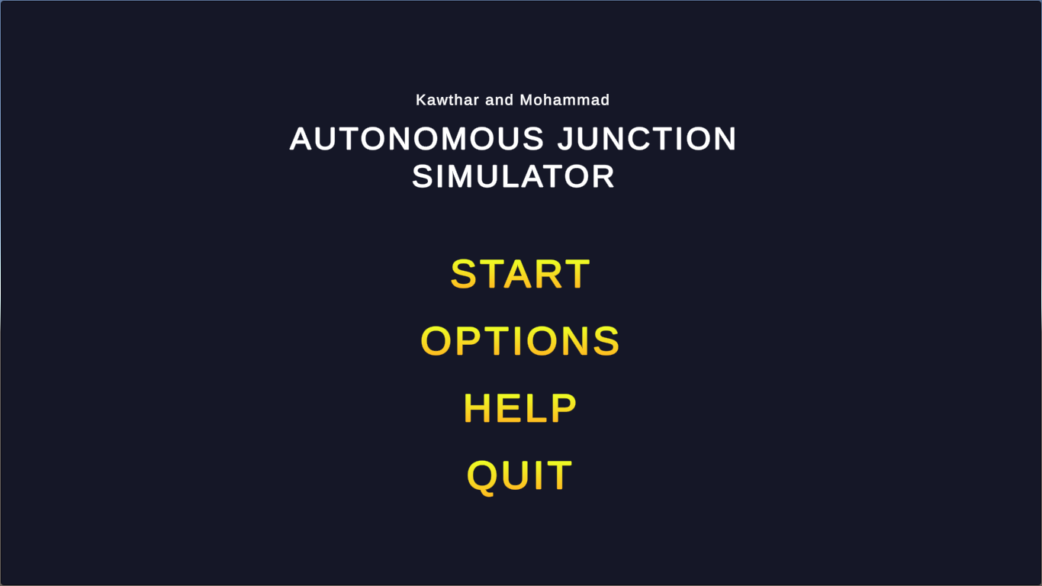

Figure 4.19: Main Menu

**Options Menu**

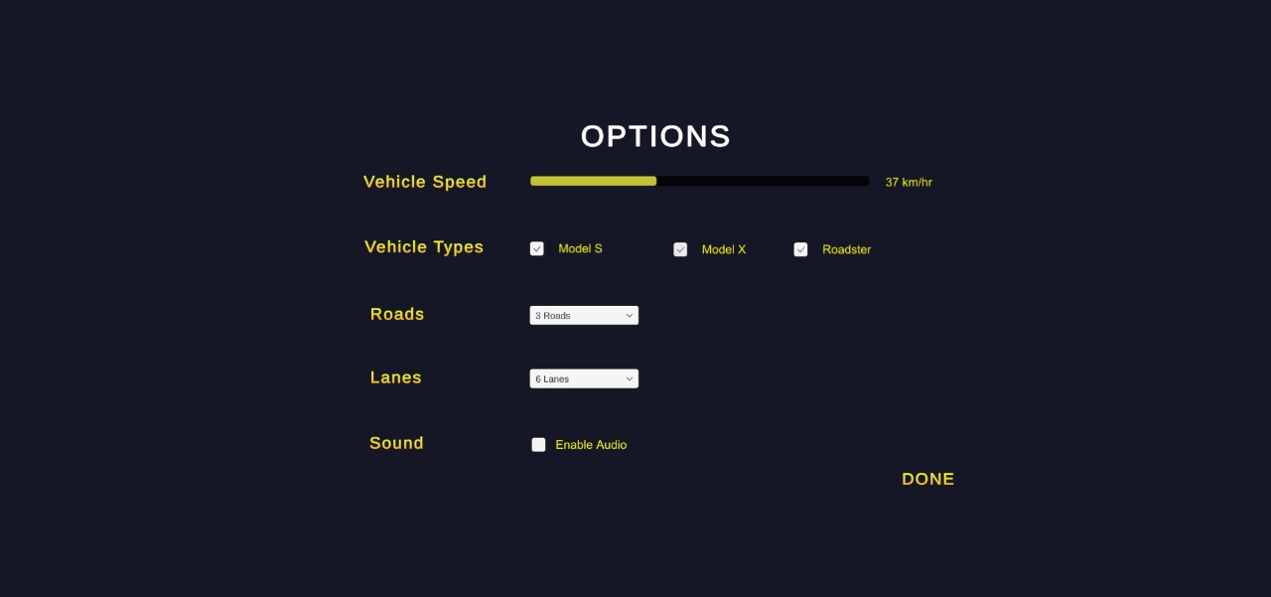

Figure 4.20: Options Menu

**Help Section**

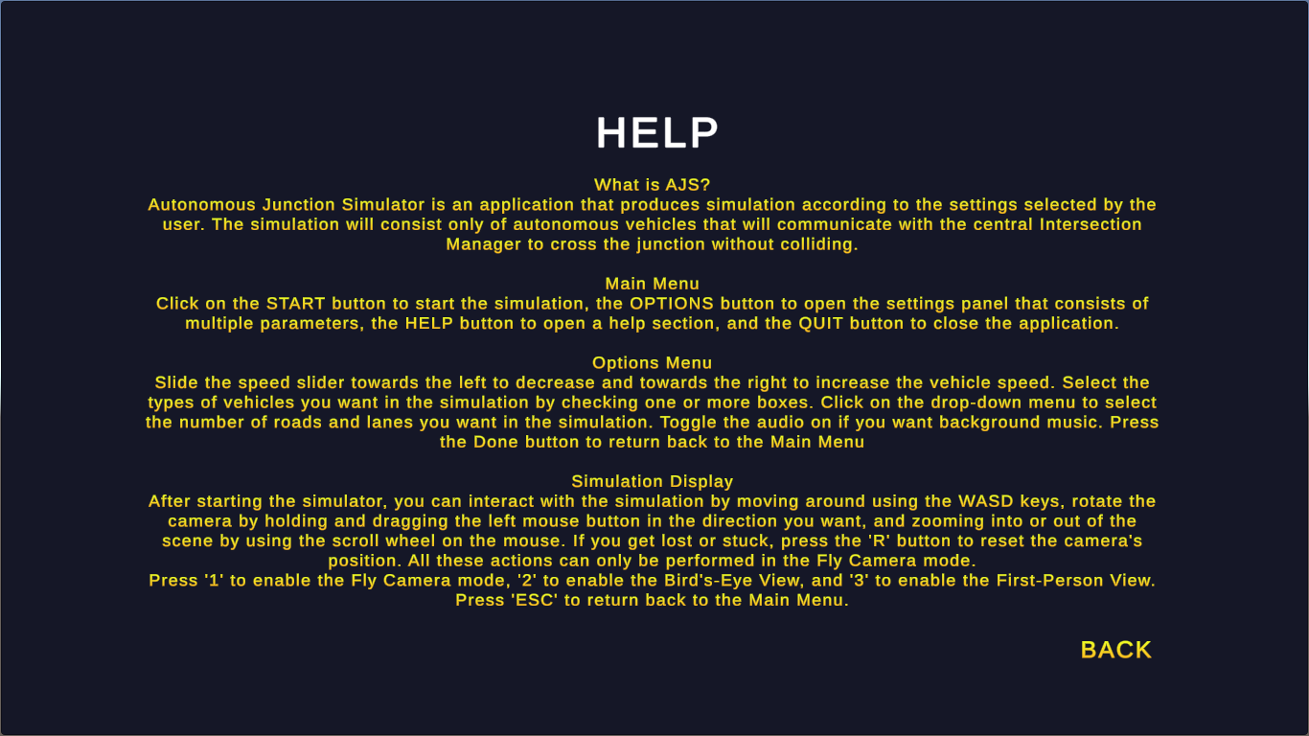

Figure 4.21: Help Section

**Simulation Consisting of 3 Roads and 2 Lanes**

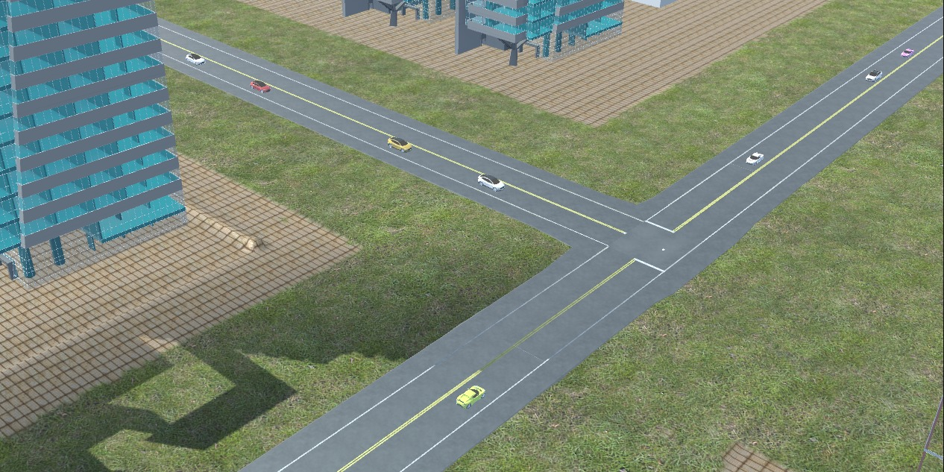

Figure 4.22: Simulation for 3 Roads and 2 Lanes

**Simulation Consisting of 3 Roads and 4 Lanes**

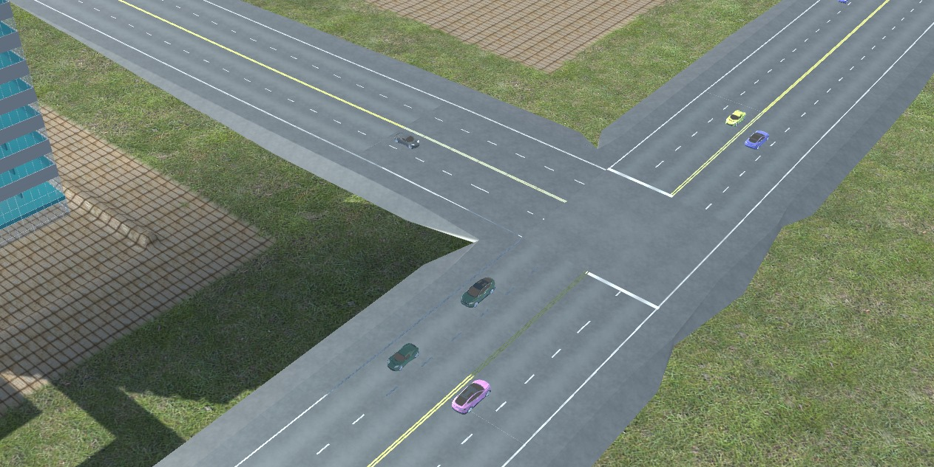

Figure 4.23: Simulation for 3 Roads and 4 Lanes

**Simulation Consisting of 3 Roads and 6 Lanes**

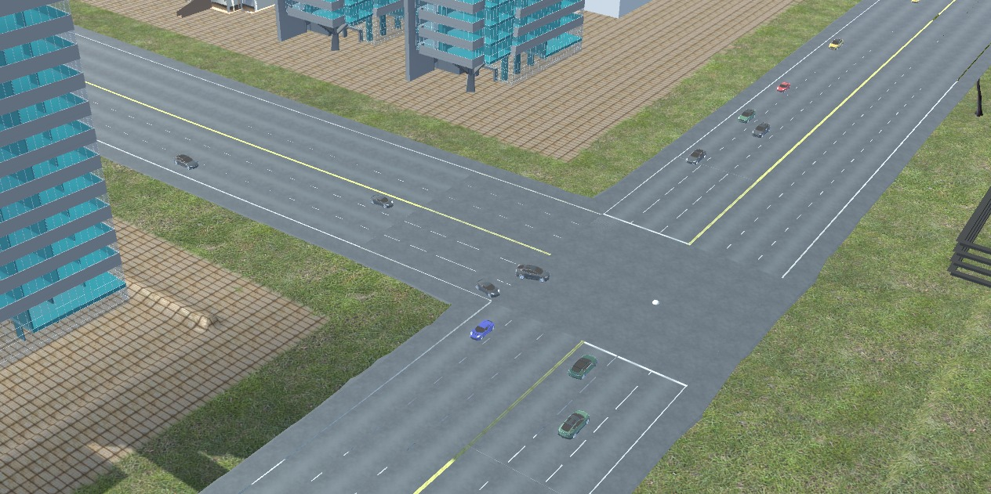

Figure 4.24: Simulation for 3 Roads and 6 Lanes

**Simulation Consisting of 4 Roads and 2 Lanes**

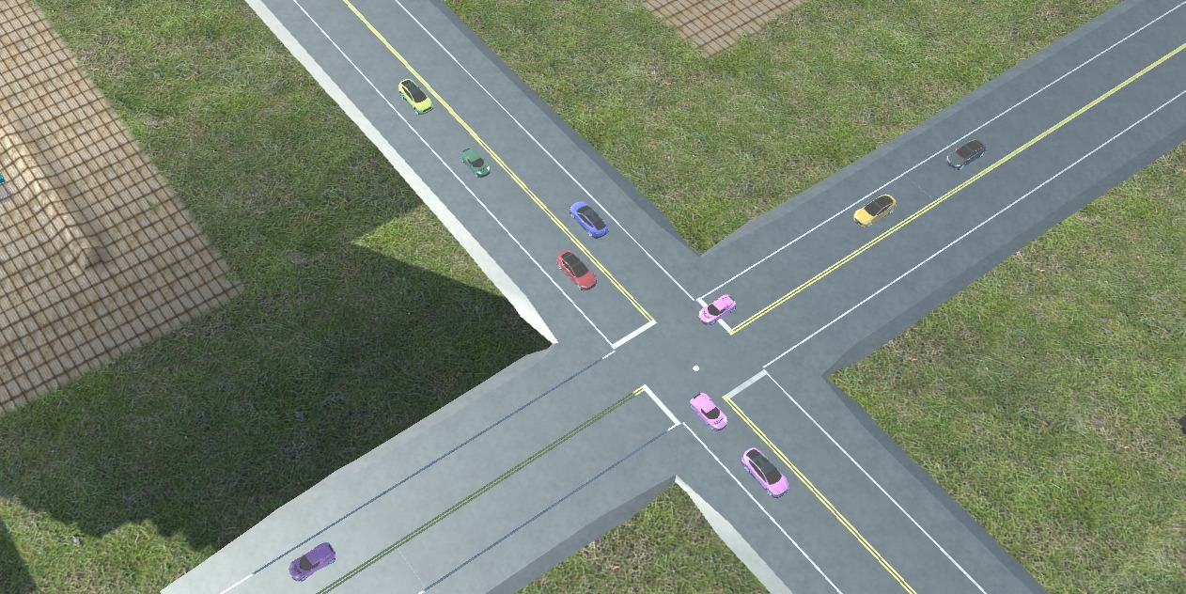

Figure 4.25: Simulation for 4 Roads and 2 Lanes

**Simulation Consisting of 4 Roads and 4 Lanes**

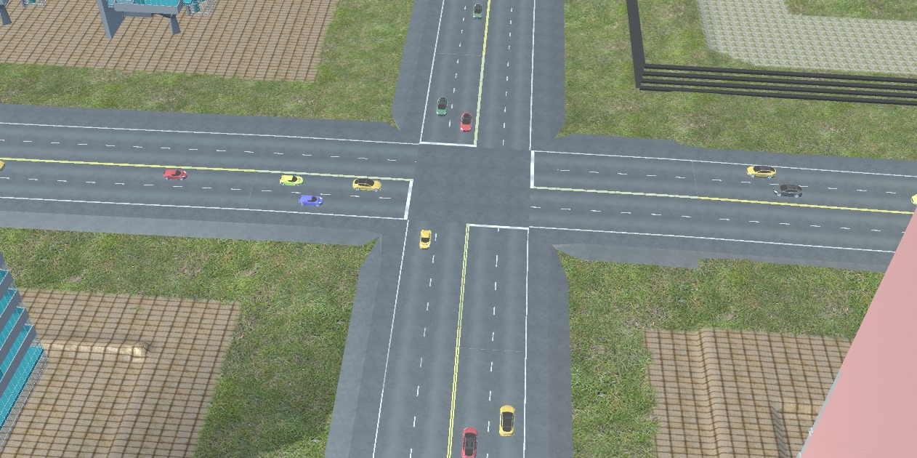

Figure 4.26: Simulation for 4 Roads and 4 Lanes

**Simulation Consisting of 4 Roads and 6 Lanes**

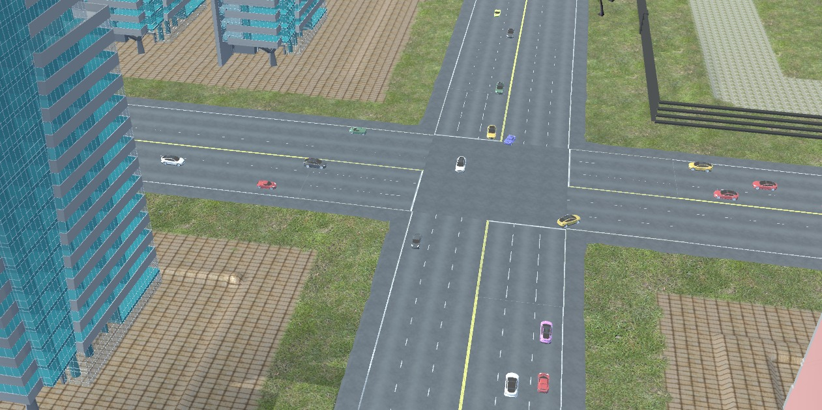

Figure 4.27: Simulation for 4 Roads and 6 Lanes

**Default Fly Camera View**

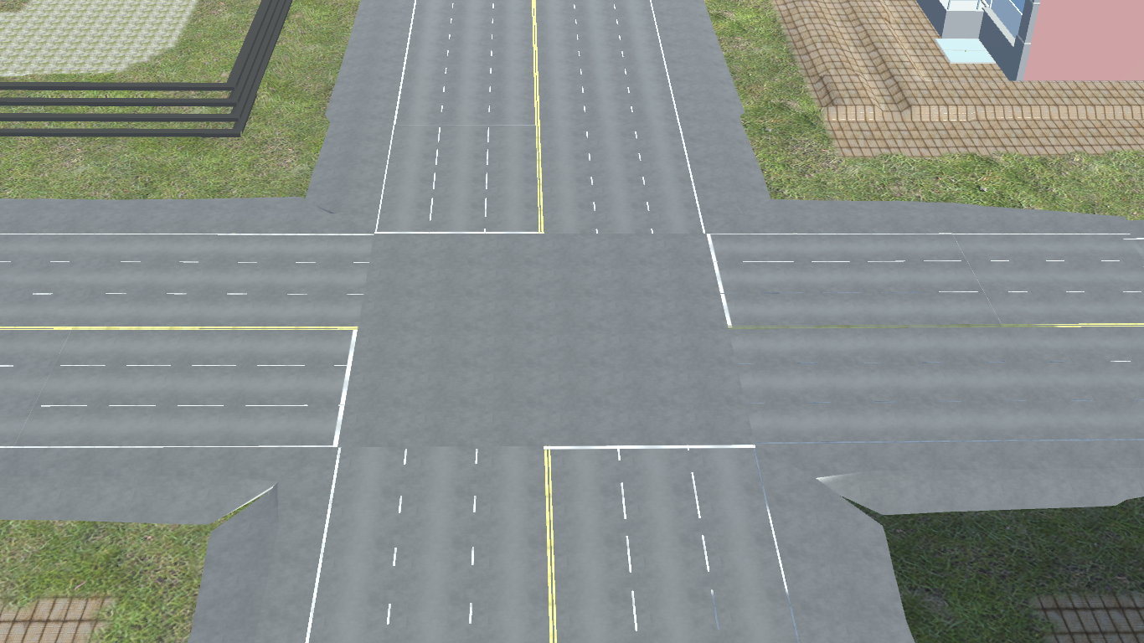

Figure 4.28: Default Fly Camera View

**Bird’s-Eye View**

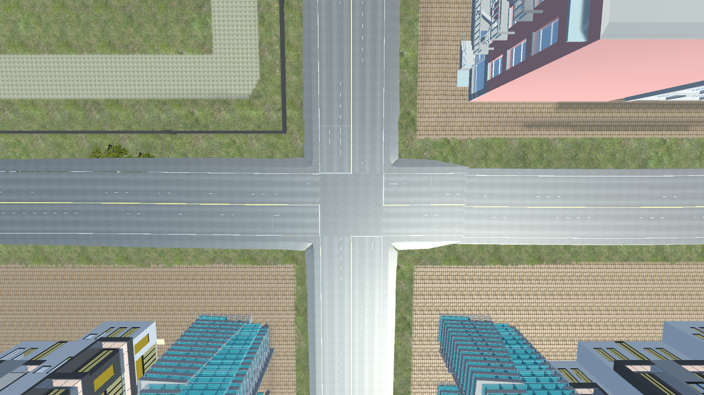

Figure 4.29: Bird’s-Eye View

**First-Person View**

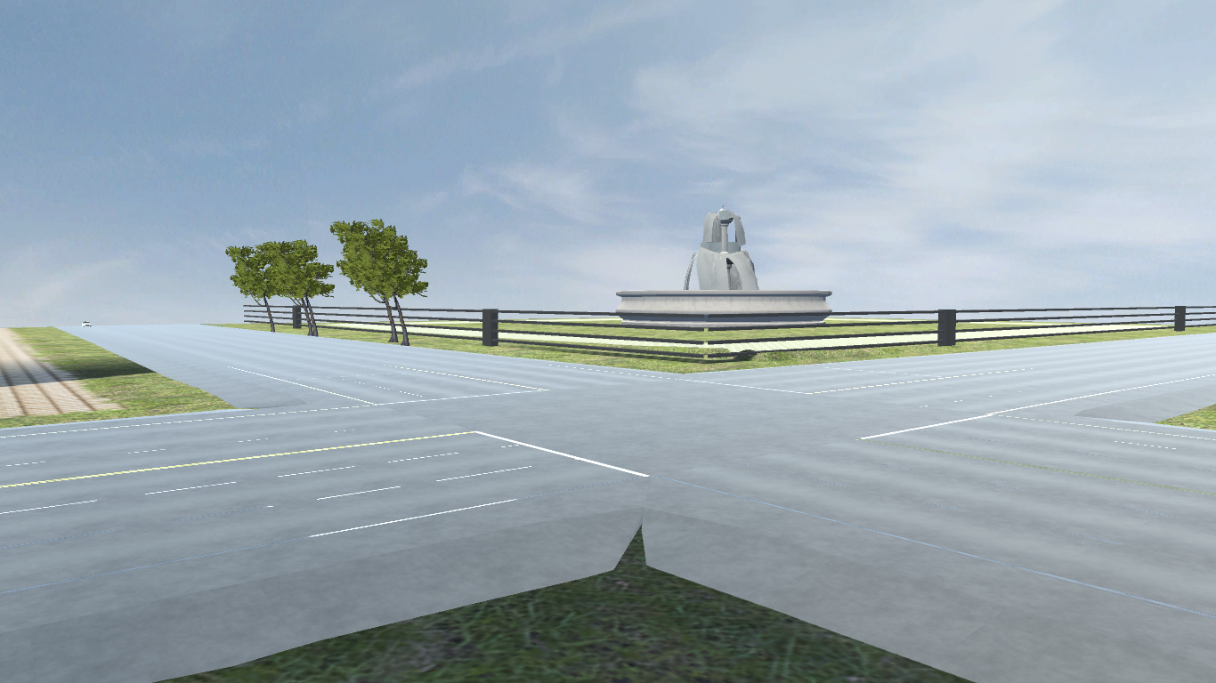

Figure 4.30: First-Person View

# Chapter Five: Test Plan



## Scope of Testing

The following modules are included for testing:

* Camera Views
* Intersection Manager
* Main Menu
* PID Controller
* Simulation Display
* Varying Parameters

## Test Plan Strategy

### Unit Testing

Critical individual modules from the entire system were identified (as listed above) and tested to ensure that the end product achieved will be flawless and of high quality. Unit test cases were prepared for comparing the result obtained with the expected result to identify errors in the individual modules and rectify them at an early stage.

### Integration Testing

After the individual units had successfully passed their unit testing phase, units were integrated together for integration testing. In unit testing, the aim was to see whether the individual modules could perform their function without errors. In integration testing, the aim was to ensure that no errors are encountered when the units are combined. If errors are encountered in integration testing, this means that the individual components are working fine and the problem arises only when they are combined, making it easy to identify and resolve the error. There are multiple methods for performing integration testing and the method selected for AJS was the incremental approach. In the incremental testing approach, two components are integrated and then tested for errors. Once they pass the test, other units are added to it incrementally. The incremental approach is further divided into two approaches; Bottom-Up and Top-Down. For AJS, the Bottom-Up strategy was selected. In the Bottom-Up approach, the modules at the lowest level are tested first, and then the higher ones up till the top-most module.

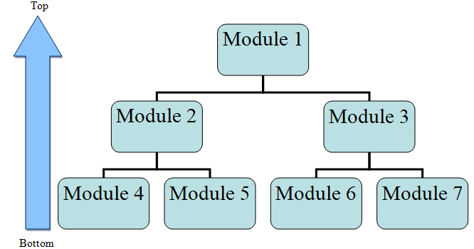

Figure 5.1: Bottom-Up Approach

### System Testing

System testing is done after unit and integration testing. This will make certain that the system developed works properly and meets the functional and non-functional requirements.

In system testing, the system is tested for the following:

* To ensure that the desired output is obtained depending on the input entered. The simulation displayed must be produced based on the options selected by the user
* End to End scenario testing: Testing the system as a whole (after integrating all modules) to see how individual modules interact with each other and how they interact with the system
* To assess the user’s experience when he/she interacts with AJS

#### Stress and Load Testing

AJS is a self-sustaining application and does not require an Internet connection after it has been downloaded, as a consequence, the load and stress is contingent on the device the application is running on. To test for stress and load, AJS was downloaded on different computers that were running the Windows operating system to check for delays and other quality-related or functionality-related bugs.

#### Usability Testing

During the development of AJS, usability has been given high priority as it is a salient component of all products. Usability testing was carried out frequently and iteratively throughout the development cycle to assess the ease of usage when end-users interact with AJS.

Due to COVID-19, observing users using the application in real-time was not possible so unmoderated remote usability testing was carried out where the users were asked to navigate through the application in the absence of the developers and without any verbal guidance. The concept of explorative testing was then applied to obtain constructive feedback from users to improve usability and to fill any gaps. This usability method helped achieve cost-friendly, robust results, and also helped with stress and load testing since the users were required to test the application on their systems (different environments). Moreover, to increase the overall usability, Norman’s 6 design principles were put into practice to maximize and ease AJS usability.

#### Security Testing

Security is a major component of all products to keep data confidential and to acquire the user’s trust. Since AJS does not contain any critical data or a database, security testing has not been performed.

#### Regression Testing

Since changes were made to the application constantly to incorporate other features, regression testing was performed to verify that the existing software is working properly after the recent changes and fulfilling the functional and non-functional requirements. If the software fails during the regression test then this means that the recent changes have affected the old code and the recent code needs to be fixed.

Regression testing was done continuously until the end of the project to make sure that the product obtained at every stage is stable and meets the specifications mentioned in the design and requirements chapters.

#### Flexibility Testing

A system is considered flexible when it has the potential to tolerate and adapt to changes. During the application development, several amendments were made to the system before reaching the final product. Changes to the functionality and interface were made quite often to meet the requirements and the system easily adapted to these modifications.

## Test Environment

AJS is a standalone desktop application that is compatible with systems running Windows 7 or higher. This project was tested on different laptops that have Windows 10 OS, a minimum of 4 GB RAM, DirectX 10, and a processor that supports the SSE2 instruction set.

## Schedule

Table 5.1: Schedule for Test Cases

|  |  |  |
| --- | --- | --- |
| Action | Members | Date |
| Preparation of Test Cases | Mohammad and Kawthar | 15th November 2020 |
| Execution of Integration Testing | Mohammad and Kawthar | 28th November 2020 |
| Execution of System Testing | Mohammad and Kawthar | 28th November 2020 to 29th November 2020 |

## Control Activities

Throughout the project development, online zoom meetings were convened weekly between the team and the supervisor and continuous discussions between the group members were carried out frequently via WhatsApp and Zoom. The team members collaborated on the project with the aid of GitHub for the implementation and Google Drive for the documentation. The supervisor was informed about the problems, possible solutions, progress done after the previous meeting, and the tasks to complete before the next meeting. These regular meetings helped the group to stay on track and complete the project before the deadlines.

## Resources

### Human

All team members:

* Mohammad Dohadwala
* Kawthar Mohammad Adam

The supervisor of this project:

* Dr. Ahsan Rehman

### Hardware

* AJS was tested on different computer systems that belonged to the team members and the laptops had the required performance specifications like Windows 10
* The hardware had at least 4 GB of RAM, a graphics card, a processor that supports the SSE2 instruction set, and DirectX 10 to support the rich multimedia content

### Software

The entire development of the project was carried out using Unity and Visual Studio Code. These software programs were also used during the testing phase as they include a debugging feature as well.

## Test Case Design and Description

Table 5.2: Test Case 5.1

|  |  |  |  |  |  |  |
| --- | --- | --- | --- | --- | --- | --- |
| **Test Case ID** | 5.1 | | | | | |
| **QA Test Engineer** | Mohammad and Kawthar | | **Reviewed By** | | Dr. Ahsan Rehman | |
| **Test Case Version** | Version 1.0 | | | | | |
| **Test Execution Date** | November 29, 2020 | | | | | |
| **Use Case Reference(s)** | UC-Men-01, Figure 3.1 | | | | | |
| **GUI Reference(s)** | Figures 4.19, 4.20, 4.21 | | | | | |
| **Objective** | To test the options on the main menu | | | | | |
| **Product / Ver/ Module** | Main Menu | | | | | |
| **Environment** | The application is installed and running | | | | | |
| **Assumption(s)** | A Windows 7 or higher OS is being used | | | | | |
| **Pre-Requisite** | The application has been started | | | | | |
| **Test Case Description** | This test will check whether or not the options on the main menu are properly mapped with their functionality | | | | | |
| **Input Parameters** | **Expected Output** | **Actual Output** | | **Test Conformance Status** | | **Possible reason(s) in case of failure** |
| Clicked on the START button | Simulation scene based on the options selected by the user is displayed | The simulation was created as per the selected options | | Passed | | Nil |
| Clicked on the OPTIONS button | A settings panel containing all varying parameters is displayed for the user to set | Various settings appeared | | Passed | | Nil |
| Clicked on the HELP button | A help section explaining AJS and its options should appear | Help section with all details appeared | | Passed | | Nil |
| Clicked on the QUIT button | The application closes | The AJS window closed | | Passed | | Nil |
| **Comments** | Nil | | | | | |

Table 5.3: Test Case 5.2

|  |  |  |  |  |  |  |
| --- | --- | --- | --- | --- | --- | --- |
| **Test Case ID** | 5.2 | | | | | |
| **QA Test Engineer** | Mohammad and Kawthar | | **Reviewed By** | | Dr. Ahsan Rehman | |
| **Test Case Version** | Version 2.0 | | | | | |
| **Test Execution Date** | November 29, 2020 | | | | | |
| **Use Case Reference(s)** | UC-Opt-01, Figure 3.2 | | | | | |
| **GUI Reference(s)** | Figures 4.20, 4.22 – 4.27 | | | | | |
| **Objective** | To test the correlation between the options selected and the simulation produced | | | | | |
| **Product / Ver/ Module** | Varying Parameters and Simulation Display | | | | | |
| **Environment** | The application is installed and running | | | | | |
| **Assumption(s)** | A Windows 7 or higher OS is being used | | | | | |
| **Pre-Requisite** | The user has selected the required options and started the simulation | | | | | |
| **Test Case Description** | This test will compare the varying parameters the user had set in the options scene with the simulated environment produced by the application | | | | | |
| **Input Parameters** | **Expected Output** | **Actual Output** | | **Test Conformance Status** | | **Possible reason(s) in case of failure** |
| Vehicle Speed is set using the speed slider | The vehicles travel at the selected speed | The vehicles travel at the selected speed | | Passed | | Nil |
| Checkbox for Model S is checked/unchecked | The simulation produced should/shouldn’t display autonomous Model S traveling on the road | The simulation contains Model S only when the checkbox is checked | | Passed | | Nil |
| Checkbox for Model X is checked/unchecked | The simulation produced should/shouldn’t display autonomous Model X traveling on the road | The simulation contains Model X only when the checkbox is checked | | Passed | | Nil |
| Checkbox for Roadster is checked /unchecked | The simulation produced should/shouldn’t display autonomous Roadster traveling on the road | The simulation contains Roadster only when the checkbox is checked | | Passed | | Nil |
| 3 or 4 Roads option is selected from the Roads drop-down menu | The simulation should consist of 3 or 4 roads | The simulation shows 3 or 4 roads based on the user’s selection | | Passed | | Nil |
| 2 Lanes option is selected from the Lanes drop-down menu | All the roads should have 2 lanes, each lane traveling in the opposite direction to the other | All roads have 2 lanes, 1 for each direction | | Passed | | Nil |
| 4 Lanes option is selected from the Lanes drop-down menu | All the roads should have 4 lanes, 2 lanes for moving towards the intersection and 2 lanes for moving away | All roads have 4 lanes, 2 for each direction | | Passed | | Nil |
| 6 Lanes option is selected from the Lanes drop-down menu | All the roads should have 6 lanes, 3 lanes for moving towards the intersection and 3 lanes for moving away | All roads have 6 lanes, 3 for each direction | | Passed | | Nil |
| The Enable Audio checkbox for sound is checked/unchecked | Audio should/shouldn’t start playing in the background | The audio plays in the background only when the checkbox is checked | | Passed | | Nil |
| **Comments** | Nil | | | | | |

Table 5.4: Test Case 5.3

|  |  |  |  |  |  |  |
| --- | --- | --- | --- | --- | --- | --- |
| **Test Case ID** | 5.3 | | | | | |
| **QA Test Engineer** | Mohammad and Kawthar | | **Reviewed By** | | Dr. Ahsan Rehman | |
| **Test Case Version** | Version 1.0 | | | | | |
| **Test Execution Date** | November 28, 2020 | | | | | |
| **Use Case Reference(s)** | UC-Men-01, Figure 3.1 | | | | | |
| **GUI Reference(s)** | N/A | | | | | |
| **Objective** | To test persistent options | | | | | |
| **Product / Ver/ Module** | Persistent options for simulation | | | | | |
| **Environment** | The application is installed and running | | | | | |
| **Assumption(s)** | A Windows 7 or higher OS is being used | | | | | |
| **Pre-Requisite** | The application is started without changing the options | | | | | |
| **Test Case Description** | This test will check whether or not the application can save the previously selected options and display the simulation based on it | | | | | |
| **Input Parameters** | **Expected Output** | **Actual Output** | | **Test Conformance Status** | | **Possible reason(s) in case of failure** |
| Clicked on the START button without going on the options screen | The simulation is displayed based on the previously saved state when the application was last run | The simulation displayed small vehicles in a 2 lane system | | Passed | | Nil |
| **Comments** | Nil | | | | | |

Table 5.5: Test Case 5.4

|  |  |  |  |  |  |  |
| --- | --- | --- | --- | --- | --- | --- |
| **Test Case ID** | 5.4 | | | | | |
| **QA Test Engineer** | Mohammad and Kawthar | | **Reviewed By** | | Dr. Ahsan Rehman | |
| **Test Case Version** | Version 1.0 | | | | | |
| **Test Execution Date** | November 28, 2020 | | | | | |
| **Use Case Reference(s)** | UC-Cam-01, Figure 3.3 | | | | | |
| **GUI Reference(s)** | Figures 4.28, 4.29, 4.30 | | | | | |
| **Objective** | To test the different camera views | | | | | |
| **Product / Ver/ Module** | Camera Views | | | | | |
| **Environment** | The application is installed and running | | | | | |
| **Assumption(s)** | A Windows 7 or higher OS is being used | | | | | |
| **Pre-Requisite** | The user has started the simulation | | | | | |
| **Test Case Description** | This test will check whether or not the user can successfully switch between the different camera views | | | | | |
| **Input Parameters** | **Expected Output** | **Actual Output** | | **Test Conformance Status** | | **Possible reason(s) in case of failure** |
| ‘1’ is pressed on the keyboard | The fly camera should get activated | The default camera is enabled and can be moved around | | Passed | | The keyboard key is not working |
| ‘2’ is pressed on the keyboard | The camera for the bird’s-eye view should get activated | The camera showing bird’s-eye view is enabled | | Passed | | The keyboard key is not working |
| ‘3’ is pressed on the keyboard | The camera for the first-person view should get activated | The camera showing the view from the junction is enabled | | Passed | | The keyboard key is not working |
| **Comments** | Nil | | | | | |

Table 5.6: Test Case 5.5

|  |  |  |  |  |  |  |
| --- | --- | --- | --- | --- | --- | --- |
| **Test Case ID** | 5.5 | | | | | |
| **QA Test Engineer** | Mohammad and Kawthar | | **Reviewed By** | | Dr. Ahsan Rehman | |
| **Test Case Version** | Version 1.0 | | | | | |
| **Test Execution Date** | November 28, 2020 | | | | | |
| **Use Case Reference(s)** | UC-Cam-02, Figure 3.3 | | | | | |
| **GUI Reference(s)** | N/A | | | | | |
| **Objective** | To test camera movement | | | | | |
| **Product / Ver/ Module** | Camera movements during simulation | | | | | |
| **Environment** | The application is installed and running | | | | | |
| **Assumption(s)** | A Windows 7 or higher OS is being used | | | | | |
| **Pre-Requisite** | The user is in the fly camera mode | | | | | |
| **Test Case Description** | This test will check whether or not the user can move around the 3-D environment smoothly by moving the camera | | | | | |
| **Input Parameters** | **Expected Output** | **Actual Output** | | **Test Conformance Status** | | **Possible reason(s) in case of failure** |
| WASD keys are pressed | The camera should move inwards, left, outwards, and right | The camera moves in, left, right, and out | | Passed | | The keyboard key is not working |
| The left mouse button is clicked, held, and dragged | The camera should tilt in the direction the mouse is swayed | The camera rotates in the direction of the cursor | | Passed | | The mouse is not working |
| The scroll wheel is moved up and down | The camera should zoom in and zoom out respectively | The camera zooms into and out of the screen | | Passed | | The touchpad is being used, the scroll wheel of the mouse isn’t functional |
| ‘R’ is pressed on the keyboard | The camera is reset to its default/start position | The camera resets to the start position | | Passed | | The keyboard key is not working |
| The camera is moved continuously far from the intersection | The camera should stop and not leave the terrain | The camera stops moving when the end of the terrain is reached | | Passed | | The keyboard key is not working |
| **Comments** | Nil | | | | | |

Table 5.7: Test Case 5.6

|  |  |  |  |  |  |  |
| --- | --- | --- | --- | --- | --- | --- |
| **Test Case ID** | 5.6 | | | | | |
| **QA Test Engineer** | Mohammad and Kawthar | | **Reviewed By** | | Dr. Ahsan Rehman | |
| **Test Case Version** | Version 1.0 | | | | | |
| **Test Execution Date** | November 29, 2020 | | | | | |
| **Use Case Reference(s)** | UC-IM-01, UC-Opt-01, Figure 3.2 | | | | | |
| **GUI Reference(s)** | Figures 4.22 – 4.27 | | | | | |
| **Objective** | To test the movement of autonomous vehicles | | | | | |
| **Product / Ver/ Module** | Intersection Manager and PID Controller | | | | | |
| **Environment** | The application is installed and running | | | | | |
| **Assumption(s)** | A Windows 7 or higher OS is being used | | | | | |
| **Pre-Requisite** | The user has started the simulation | | | | | |
| **Test Case Description** | This test will check whether or not the vehicles are moving in their lanes and are crossing the junction without colliding | | | | | |
| **Input Parameters** | **Expected Output** | **Actual Output** | | **Test Conformance Status** | | **Possible reason(s) in case of failure** |
| Clicked the START button on the Main Menu | The vehicles should get spawned randomly | Vehicles are getting spawned randomly on all sides | | Passed | | Nil |
| Selected 2 lanes and clicked on the START button on the Main Menu | The vehicles should cross the junction in their respective direction without colliding in the 2 lane system | 2 lane system is displayed where vehicles are crossing the junction in all directions without colliding | | Passed | | Nil |
| Selected 4 lanes and clicked on the START button on the Main Menu | The vehicles should cross the junction in their respective direction without colliding in the 4 lane system | 4 lane system is displayed where vehicles are crossing the junction in all directions without colliding | | Passed | | Nil |
| Selected 6 lanes and clicked on the START button on the Main Menu | The vehicles should cross the junction in their respective direction without colliding in the 6 lane system | 6 lane system is displayed where vehicles crossing the junction in all directions without colliding | | Passed | | Nil |
| Clicked the START button on the Main Menu | The vehicles should travel in their respective lanes | The vehicles are traveling in their lanes | | Passed | | Nil |
| ‘ESC’ is pressed on the keyboard | The Main Menu should be displayed | The Main Menu appears | | Passed | | The keyboard key is not working |
| **Comments** | Nil | | | | | |

## Status Reporting

A comparison between the progress and the plan was carried out to check for any deviations from the desired plan. The status was discussed among the team members and with the supervisor to determine the necessary actions needed to comply with the requirements and objectives of the project.

## Major Deliverables

* Test Plan: It specifies the testing strategies used for the testing of AJS to achieve a high-quality end product
* Test Cases: It focuses on the expected and actual output received when various modules of the project were tested

## Risks and Assumptions

* All members testing the application have a thorough understanding of it
* The system used for testing must have Windows 7 or higher
* The application is already installed onto the system
* All vehicles follow the right-hand lane drive system
* Vehicles cannot make U-turns
* Vehicles stop at the intersection when the intersection is busy

## Exit Criteria

Testing the system will end when:

* All test cases have run successfully
* The completed working product has fulfilled all requirements
* All critical and high priority bugs have been resolved

# Chapter Six: Critical Evaluation



## Success Criteria

The most crucial success criterion for this project is the creation of the simulation based on the parameters set by the user. This is the main purpose of this project, without which the project will fail. Moreover, completing the application with high quality and usability standards before the deadline is also another success criterion of this project.

## Degree of Success

The proposal presented at the start of the Final Year Project was juxtaposed with the project developed at the end to determine the degree of success which is nearly 80%. The remaining 20% could not be achieved due to various constraints like time limitation, lack of similar projects for reference and the immense code and math complexity required for developing this project.

## Learning Experience

### Research Techniques

The team members acquired knowledge of the following research techniques during this project:

* Preliminary research including feasibility analysis, literature review, and comparative analysis
* Appropriate development methodology and tool selection
* Requirements elicitation and reconciliation
* Code integration
* Testing and debugging techniques

### Tools

The following tools were used for the development of AJS:

* Unity (main platform)
* Visual Studio Code for scripting
* Microsoft Word and Google Docs for documentation
* Google Slides for presentations
* GitHub for project collaboration
* Google Drive for document collaboration
* Creately for creating the diagrams

## Assumptions and Limitations

* A CPU that is 5th generation or above, has 4 GB of RAM, a processor that supports the SSE2 instruction set, DirectX 10 to support the rich multimedia content and a GTX 660 graphics card or above is required for the smooth experience and stable FPS during the simulation. Moreover, the system running AJS must have Windows 7 or higher to avoid compatibility issues
* AJS is for environments consisting of only fully autonomous vehicles because the simulation does not have traffic lights. Removing traffic lights in the presence of human drivers or partially autonomous vehicles can cause chaos and give undesirable results
* AJS does not accommodate cyclists, motorcyclists, emergency vehicles, and pedestrians in its simulation. The vehicles will travel in all directions but will not make U-turns. When the intersection is busy, the vehicles will stop
* An internet connection will be required to download AJS. Once downloaded, it can run offline

## Future Enhancements

A variety of different features could have been added to this project but due to time restriction, the features of this application have been limited to a minimum. In the future, the application can have vehicle platooning to maximize road utilization. Moreover, the application can have support for pedestrians, motorcyclists, cyclists, heavy vehicles and emergency vehicles to bring it more close to reality so that when AJS is used for practical implementations, the success rate will be higher. Also, the vehicles can be coded to perform U-turns and the application can be migrated to machines with other operating systems.

# References

[1] Sorrel, C., 2016. Fast Company. [Online] Available at: https://www.fastcompany.com/3058280/on-these-mit-designed-streets-there-are-no-traffic-lights-or-need-to-stop-at-all [Accessed 20 May 2020].

[2] Tsz-Chiu Au, Shun Zhang & Peter Stone, 2015. *Autonomous Intersection Management for Semi-Autonomous Vehicles*. Austin: University of Texas.

[3] Gopal, R., 2018. [Online] Available at: https://www.ccsinsight.com/blog/a-world-without-traffic-lights/ [Accessed 20 May 2020].

# Appendix A: Glossary

|  |  |
| --- | --- |
| 3-D | Any video or image that can be measured in 3 directions is known as 3 Dimensional |
| AJS | Autonomous Junction Simulator simulates junctions used by autonomous vehicles without traffic lights |
| FPS | Frames per second is used to define the rate at which frames or images appear on the screen |
| GPU | Graphics Processing Unit is located inside the computer and is responsible for producing the output to the screen |
| Intersection Manager | It is located at the center of the intersection and is responsible for accepting or declining the requests of vehicles to pass the junction after analyzing the current situation |
| OS | Operating System is a computer program installed into the computer for managing hardware and providing services |
| PBA | Permission-based architecture is an architecture used by AJS to accept or reject requests of autonomous vehicles to pass the intersection |
| Terrain | Terrain is the land |
| Unity | The cross-platform game engine developed by Unity Technologies |

# Appendix B: User Manual

# 

User Manual

for the

Autonomous Junction Simulator

Version 1.0

24/12/2020

**Table of Contents**

1.0 Introduction 76

2.0 Overview 77

2.1 Conventions 77

3.0 Getting Started 78

3.1 Set-up Considerations 78

3.2 User Access Considerations 78

3.3 Accessing the System 79

3.4 System Organization & Navigation 79

3.4.1 Main Menu 79

3.4.2 Options Menu 79

3.4.3 Simulation Display 79

3.5 Exiting the System 79

4.0 Using the System 80

4.1 Main Menu 80

4.1.1 Start 80

4.1.2 Options 81

4.1.3 Help 81

4.1.4 Quit 82

4.2 Options Menu 82

4.2.1 Vehicle Speed 82

4.2.2 Vehicle Type 82

4.2.3 Roads 82

4.2.4 Lanes 83

4.2.5 Audio 83

4.3 Camera Views 83

4.3.1 Fly Camera 83

4.3.2 Bird’s-Eye View 84

4.3.3 First-Person View 85

4.4 Fly Camera 85

4.4.1 Camera Movement 85

4.4.2 Camera Rotation 85

4.4.3 Camera Zoom 85

4.4.4 Camera Reset 86

4.5 Intersection Manager 86

5.0 Troubleshooting & Support 87

5.1 Error Messages 87

5.2 Special Considerations 87

5.3 Support 87

**Table of Figures**

Figure 4.1: Main Menu 80

Figure 4.2: Options Menu 81

Figure 4.3: Help Section 82

Figure 4.4: Fly Camera 84

Figure 4.5: Bird’s-Eye View 84

Figure 4.6: First-Person View 85

**List of Tables**

Table 2.1: Conventions 77

Table 5.1: Support Point of Contact 87

1. Introduction

This User Manual will assist the intended users of AJS by providing them with the required information about the system.

1. Overview

AJS is a 3-D road junction simulator for autonomous vehicles. AJS simulates a road intersection where there will be no traffic lights and fully autonomous vehicles will be able to cross the junction without colliding. With AJS, users will simulate the scenario with varying parameters like users can change the speed of vehicles, types of vehicles, number of roads and lane count.

AJS will show the users how autonomous vehicles communicate with the Intersection Manager to cross the junction using a PBA where each vehicle will be either allowed to cross if it is safe or the vehicle will stop to avoid collisions. The users can use the bird’s-eye and first-person camera views according to their preference and can move around the 3-D space in all directions when the fly camera mode is enabled. If the users face any sort of difficulty while operating the simulator due to unfamiliarity, they can also access the help section besides this user manual.

* 1. Conventions

Table 2.1: Conventions

|  |  |
| --- | --- |
| Term | Definition |
| AJS | Autonomous Junction Simulator is the name of the project |
| AV | Autonomous Vehicle |
| PBA | Permission-Based Architecture is used for providing permissions to vehicles in order to cross the intersection when it is safe to do so |
| Simulator | A machine or program which imitates a situation or scenario |
| User | The person operating the simulation |

1. Getting Started
   1. Set-up Considerations

AJS has been designed to work on systems that have Windows 7 or higher. To mitigate difficulties while operating AJS please ensure that the system fulfills the following requirements for a smooth experience:

* A CPU that is 5th generation or above
* A minimum of 4GB RAM
* DirectX 10
* A GTX 660 graphics card or above
  1. User Access Considerations

This system has been developed mainly for the following users:

1. Vehicle and Transport Department: Since AJS is a simulator, the Vehicle and Transport Department of all countries can use it to plan the infrastructure of road junctions. They can alter the variables according to the area for which they are planning to build the junction, and can test the scenarios on the simulator. AJS will be a convenient platform for these users and will help them wisely plan their designs. They will be using AJS frequently to obtain reliable results and to ensure that when the junction is implemented on the road, the outcome will be favorable. This makes them the most important user class to be satisfied since this project revolves around the simulation of road junctions.
2. Self-driving car manufacturers: Many big companies like Google are developing and testing autonomous vehicles. Since AJS gives users the freedom to select their vehicle type, these companies or manufacturers can use AJS to test the efficiency of their produced vehicles when road junctions without traffic signals will be implemented.
3. Researchers: Researchers from various organizations like MIT and the University of Texas can use AJS for their research purposes. They can use the results obtained from AJS in their research papers and suggest improvements to make AJS a more robust simulator.
   1. Accessing the System

To download the application, please visit the link given below:

<https://link.dohad.dev/ajs>

Once the application has been downloaded, the user may proceed to the main menu and avail the features.

* 1. System Organization & Navigation

This section will elucidate how the different components of AJS have been organized and how the user will navigate from one component to another.

* + 1. Main Menu

After downloading and starting the application, the main menu will be displayed. The user can click on the buttons in the menu.

* + 1. Options Menu

The options menu will contain all the varying parameters. The user can select the settings in a top to bottom manner. Once done, the user may click on the ‘Done’ button to get back to the main menu and start the simulator.

* + 1. Simulation Display

After clicking on the start button from the main menu, the simulation will be begin based on the user’s settings. The user can move around the 3-D environment, switch between different camera views or return to the main menu.

* 1. Exiting the System

To exit AJS, click on the Quit button located on the main menu

1. Using the System

This section is divided into multiple sub-sections that provide step-by-step directions on using the system and accessing the features of AJS.

* 1. Main Menu

The user can start the simulation directly or can proceed to the options menu to select the parameters. In case of any difficulty or uncertainty, the user may access the help section as well.



Figure 4.1: Main Menu

* + 1. Start

By clicking on the start button, the simulation will begin. If the user doesn’t alter the settings and clicks directly on the start button, the system will create a simulation based on the settings that were selected previously. This is done with the help of persistent data.

* + 1. Options

By clicking on the options button, a set of options will appear that can be set by the user based on his/her preferences.



Figure 4.2: Options Menu

* + 1. Help

The help section can be accessed by clicking on the help button. The help section will list down the details that are required for operating the system. Once done, the user can return to the main menu by clicking on the ‘Back’ button.



Figure 4.3: Help Section

* + 1. Quit

Clicking on the quit button will close the application.

* 1. Options Menu

The options menu will display a range of parameters that can be set by the user. Once done, the ‘Done’ button can be clicked to return to the main menu.

* + 1. Vehicle Speed

A slider is placed for setting the speed of the vehicles. When the slider is moved to the left, the speed will decrease and when the slider is moved to the right, the speed will increase. The speed set will be displayed on the right of the slider

* + 1. Vehicle Type

3 checkboxes are placed for Model S, Model X, and Roadster. A minimum of 1 and a maximum of 3 boxes can be checked. The vehicles selected will be used in the simulation.

* + 1. Roads

A drop-down menu is present for selecting the number of roads in the simulation. The 2 available options are 3 roads and 4 roads. When the 3 roads option is selected, the simulation will consist of a 3-way intersection and when the 4 roads option is selected, the simulation will consist of a 4-way intersection.

* + 1. Lanes

A drop-down menu is present for selecting the number of lanes the roads will have. The available options are 2, 4, and 6.

When the lane count is set to 2, each road will have 2 lanes, one lane for traveling towards the intersection and one lane for traveling away from the intersection.

When the lane count is set to 4, each road will have 4 lanes, two lanes for traveling towards the intersection and two lanes for traveling away from the intersection.

When the lane count is set to 6, each road will have 6 lanes, three lanes for traveling towards the intersection and three lanes for traveling away from the intersection.

* + 1. Audio

A check box for audio is placed at the bottom of the options menu. Checking it will play the background music and unchecking it will stop the background music.

* 1. Camera Views

The user can activate only one camera view at a time once the simulation begins.

* + 1. Fly Camera

This is the default camera view that will be enabled when the simulation starts. As the name suggests, the fly camera can be moved around in the 3-D space. If the user is in another view and wants to activate the fly camera, the user can press the ‘1’ key from the keyboard.



Figure 4.4: Fly Camera

* + 1. Bird’s-Eye View

The birds-eye view can be enabled by pressing the ‘2’ key from the keyboard. It will display a top-down view of the entire scene. However, the user cannot move around when this view is enabled.



Figure 4.5: Bird’s-Eye View

* + 1. First-Person View

The first-person view can be enabled by pressing the ‘3’ key from the keyboard. It will display a view of the intersection, just like a pedestrian would see. However, the user cannot move around when this view is enabled.



Figure 4.6: First-Person View

* 1. Fly Camera

When the fly camera is activated, the users can move around the 3-D environment and explore it.

* + 1. Camera Movement

To move around, the user will have to press the WASD keys on the keyboard. The ‘W’ key will move the camera close to the terrain, the ‘A’ key will move the camera to the left, the ‘S’ key will move the camera to the right and the ‘D’ key will move the camera far from the terrain.

* + 1. Camera Rotation

To rotate the camera, press the left mouse button and drag it while holding it. This will rotate the camera in the direction it is being dragged.

* + 1. Camera Zoom

The scroll wheel of the mouse will zoom into and out of the scene.

* + 1. Camera Reset

If the camera gets stuck or lost in the 3-D environment, the ‘R’ key can be pressed to reset the fly camera. The camera will be repositioned to its starting or default location.

* 1. Intersection Manager

This feature will ensure that the vehicles do not collide with each other. To return to the main menu, the user may press the ‘ESC’ button.

1. Troubleshooting & Support

This section will discuss all the possible errors that may arise and the corrective active required to resolve the error.

* 1. Error Messages

An error message regarding compatibility may appear if the host system does not have Windows 7 or higher. In this situation, the user will have to first install the Windows operating system.

* 1. Special Considerations
* If any of the keyboard-related actions are not working, check whether your keyboard is functioning properly
* If the camera is not moving, rotating or zooming, please ensure that the fly camera mode is enabled by pressing the ‘1’ key from the keyboard
* If the zoom in/out function is not working, please ensure that you are using a separate mouse and not the touchpad. Also, make sure that the mouse is connected to the system and the scroll wheel is working. The same applies to problems in camera rotation
* If the application is lagging, please ensure that the host system has the required specifications mentioned in section 3.1.
  1. Support

In case of any other issue, please contact the following pupils:

Table 5.1: Support Point of Contact

| Contact | Organization | Email |
| --- | --- | --- |
| Mohammad Dohadwala | SZABIST, Dubai | mohammad@dohad.dev |
| Kawthar Mohammad Adam | SZABIST, Dubai | kausaradam98@gmail.com |

# Turnitin Originality Report

